**QA Test For Plugin in WordPress With Test Evidence**

**Plugin Name**: QA-task-test (QA Test)

**WordPress Version**: Version 6.1.1

**Test Date**: 06-Dec-22

**Executed by**: Olufemi Oduwole

**Test Description**: Verify all functionality of plugin are functioning as expected in WordPress.

**Precondition**: Install and activate plugin in WordPress.

**Defect Report**: See end of document.

**Test 01**

Verify plugin can be successfully installed and activated in WordPress.

**Test Outcome** – **PASSED**

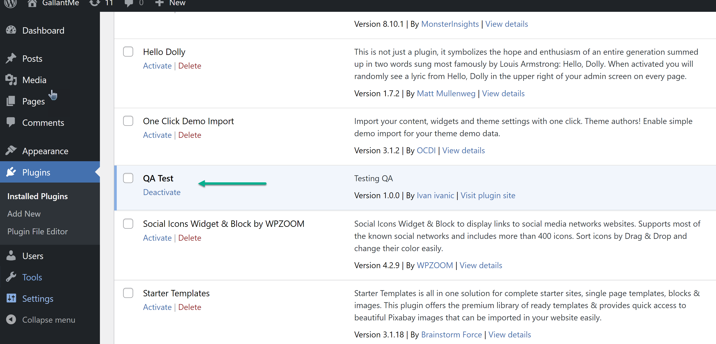

**Test 02**

Verify plugin can be accessed successfully from the Settings section.

**Test Outcome – PASSED**

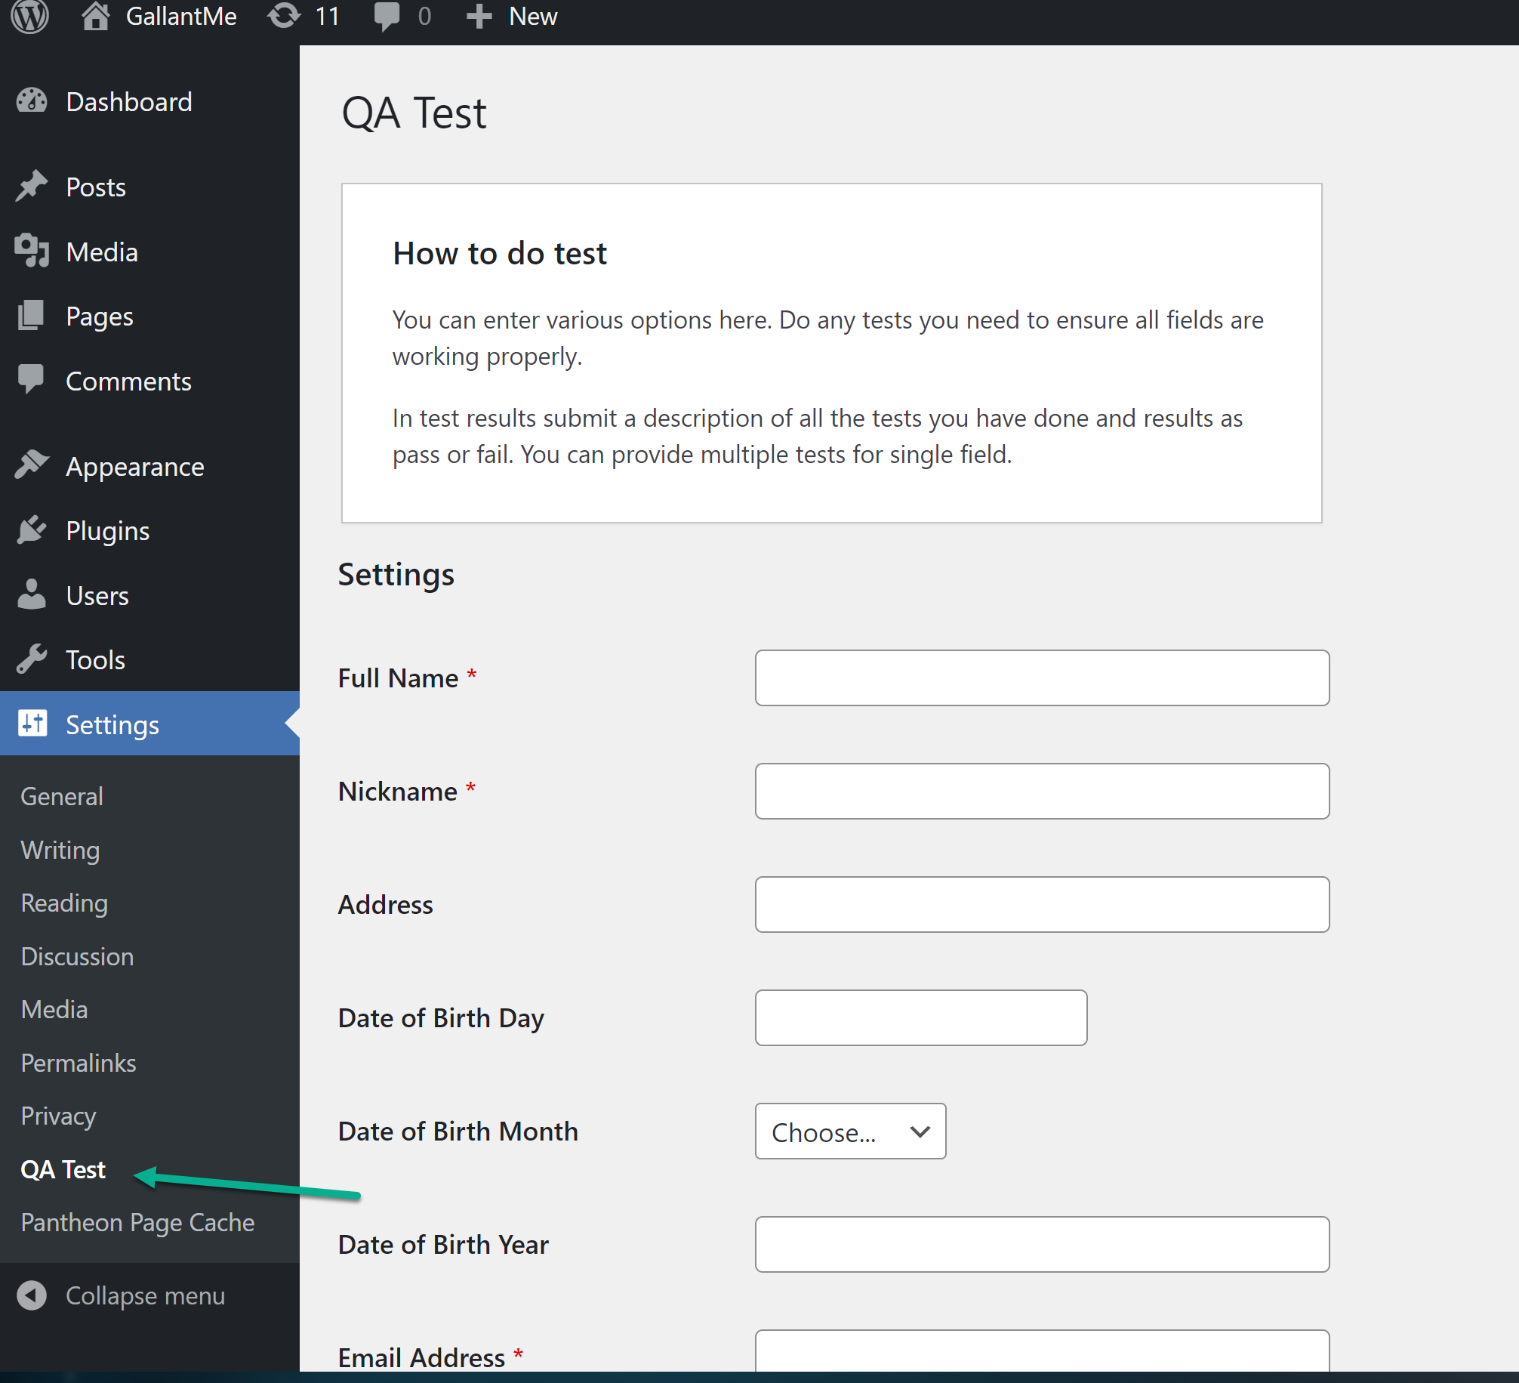

**Test 03**

Verify that all required fields must be filled out in order to save page.

**Test Approach**: This test was executed by not having any fields populated and the “Save Changes” bottom was clicked.

**Test Outcome: FAILED**

**Expected Result**: Only all the required fields (indicated with the red asterisk) should throw a required field error message.

**Actual Result**: Some non-required field(s) threw an error message; while some required field(s) did not throw an error message.

**Result details:**

* The “Address” field SHOULD NOT throw an error message but did. – Failed - A defect
* The “Nickname” field and the “Email Address” field SHOULD throw an error message but did not. – Failed - A defect
* The “Fullname” field SHOULD throw an error message and did. – Passed

**Evidence** - **FAILED**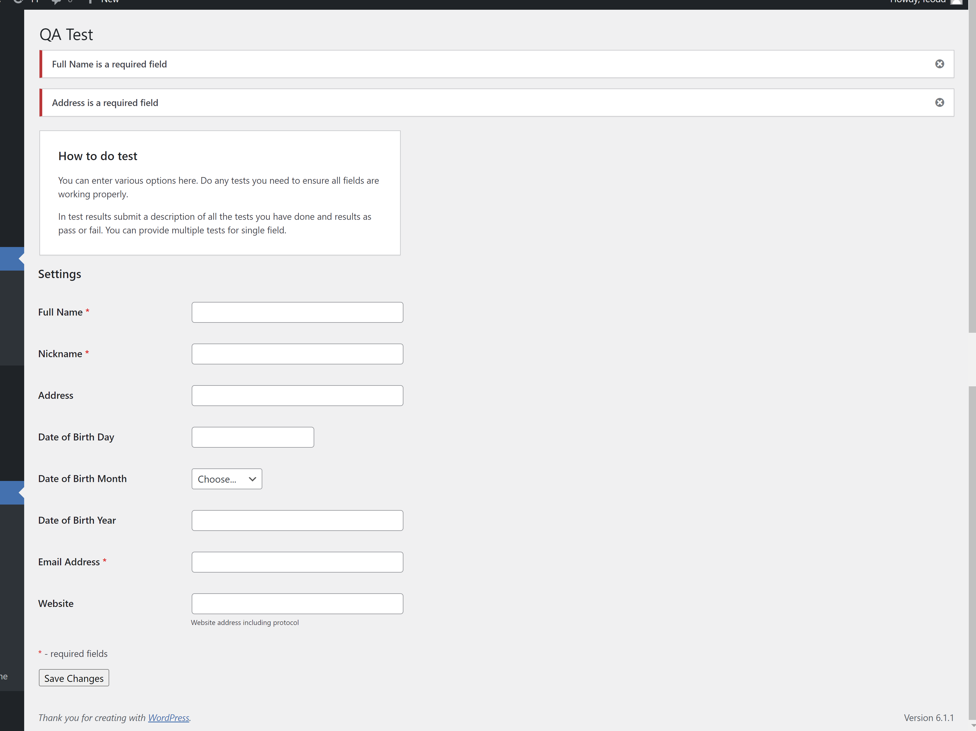

**Test 04**

Verify that all populated fields retain their data after the page is saved succesfully.

**Test Approach**: This test was executed by having all fields populated and the “Save Changes” bottom was then clicked.

**Test Outcome: FAILED**

**Expected Result**: All fields should retain all their populated data after the page is saved succesfully.

**Actual Result**: All fields did NOT retain all their data after the page is saved succesfully.

**Result details**:

* Both the “Nickname” and the “Website” fields did not retain their data. – Failed – Defects.
* All other fields retained their data properly. - Passed.

**Evidence**: All fields were filled before clicking the “Save Changes” button.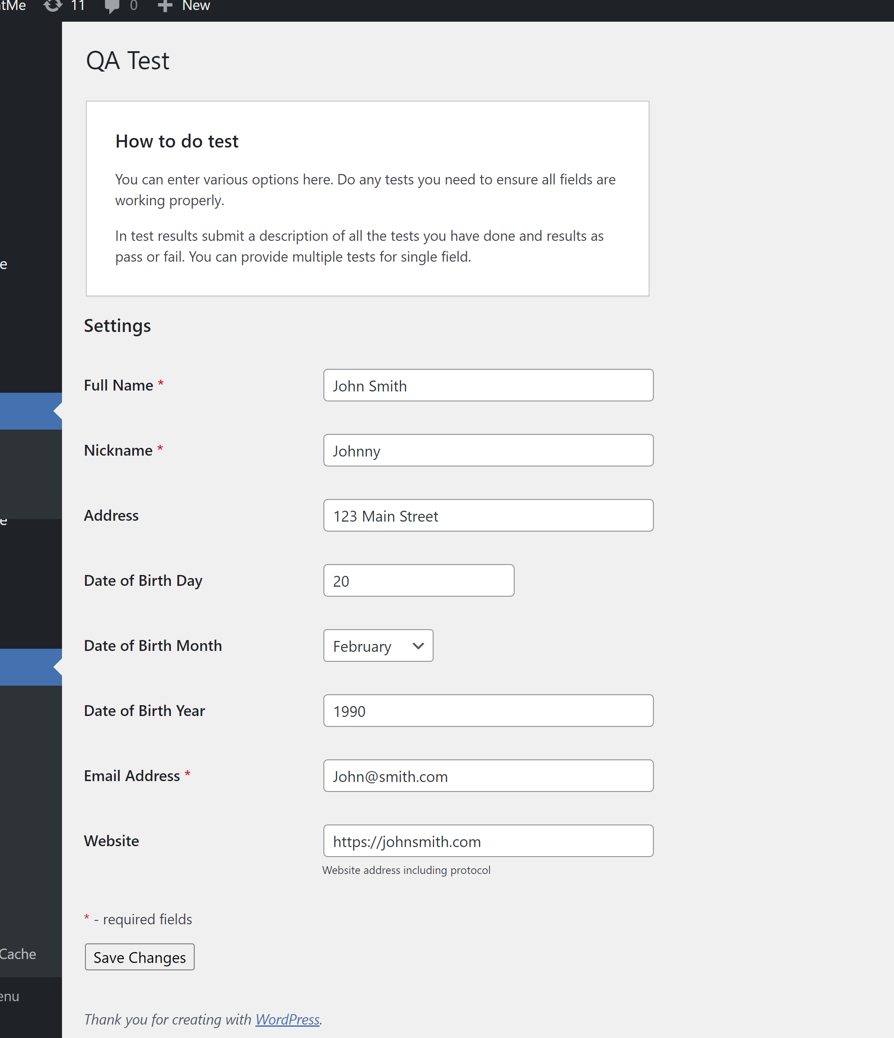

**Evidence**: The “Nickname” field and the “Website” field did NOT retain their data after saving the page. **FAILED**.

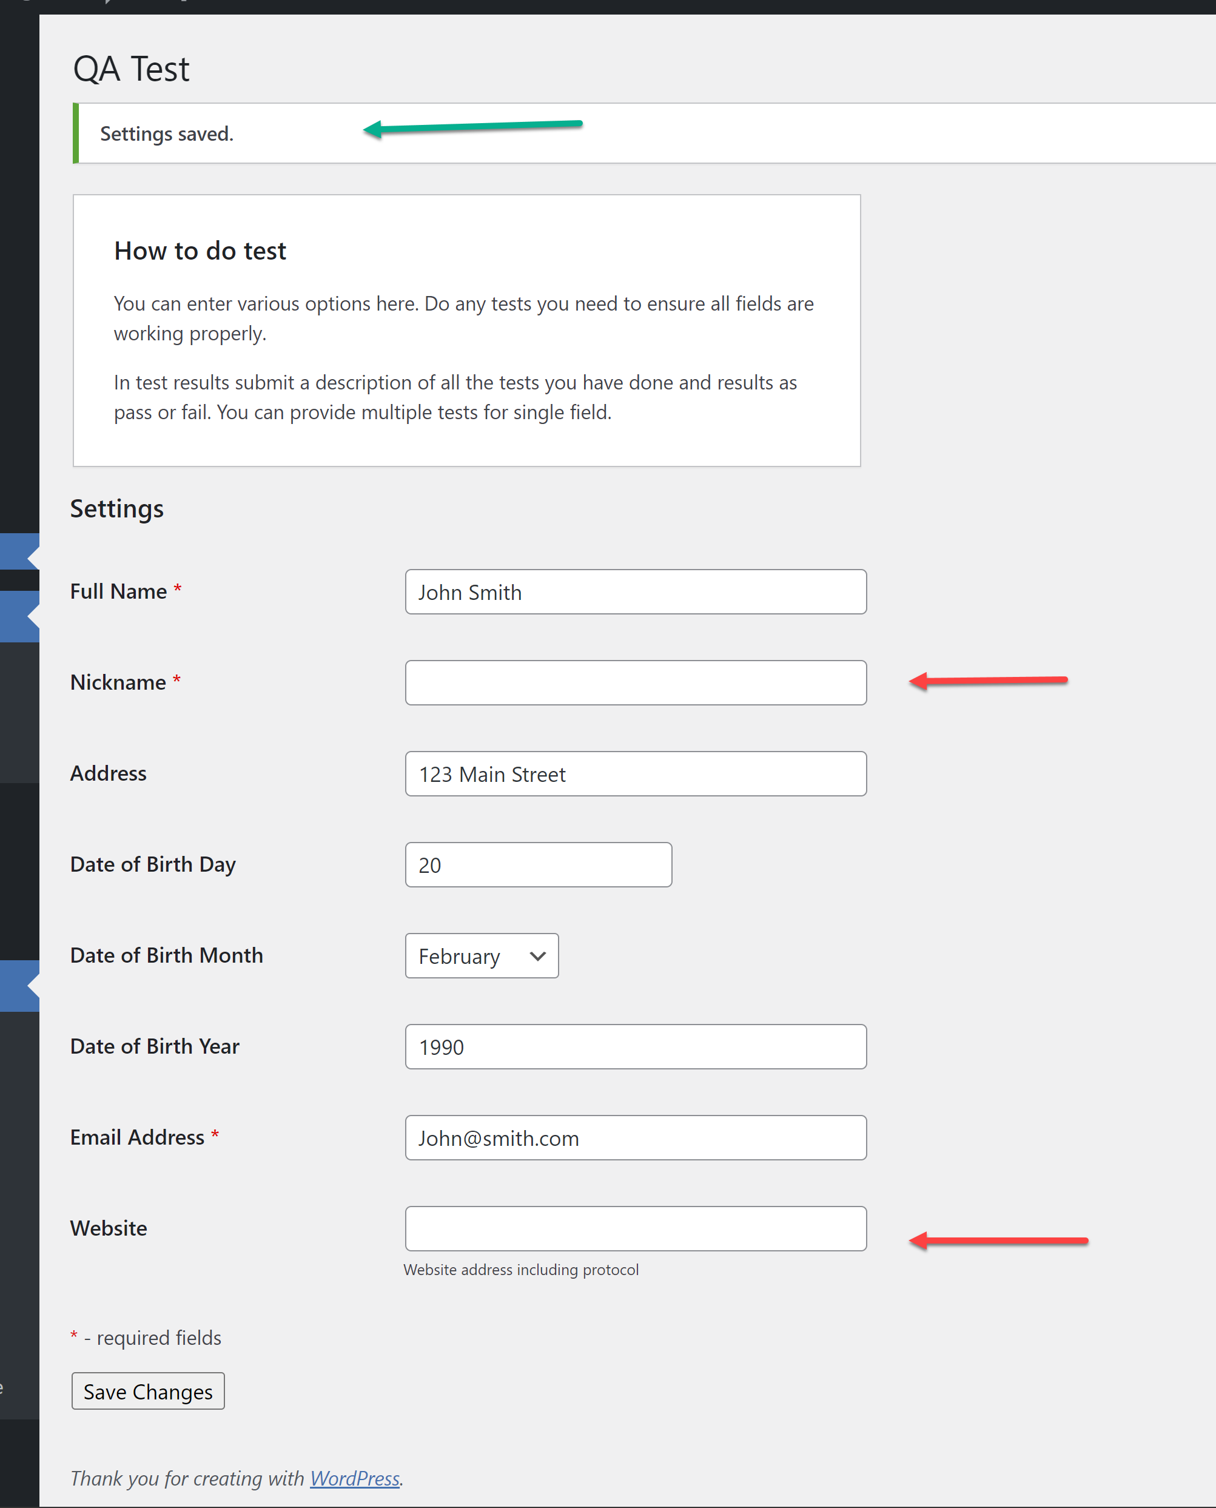

**Test 05**

Verify that **if** all required fields are not filled, then the user cannot save the page.

**Test Approach**: This was tested by filling out all required fields except the “Full Name” field.

**Test Outcome: PASSED**

**Expected Result**: Error message should be thrown for the “Full Name” field, and user should NOT be able to save page.

**Actual Result**: Error was thrown for the “Full Name” field, and user was NOT able to save page.

**Evidence**: All required fields filled except The “Full Name” field before clicking “Save Changes” button. 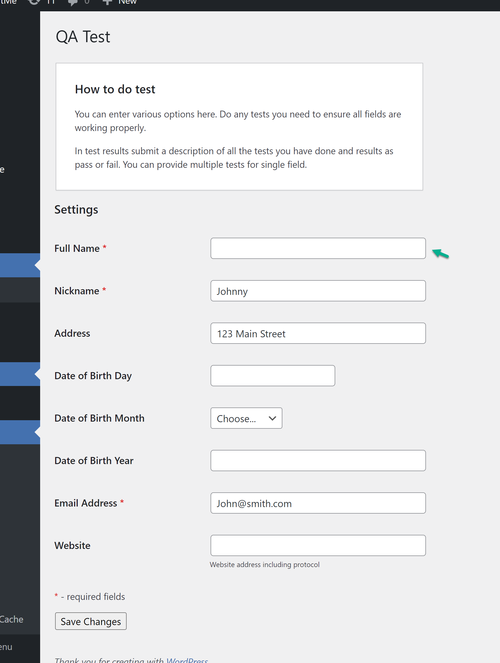

**Evidence**: Error was thrown for the unpopulated required “Full Name” field and user was NOT able to save page. – **PASSED**.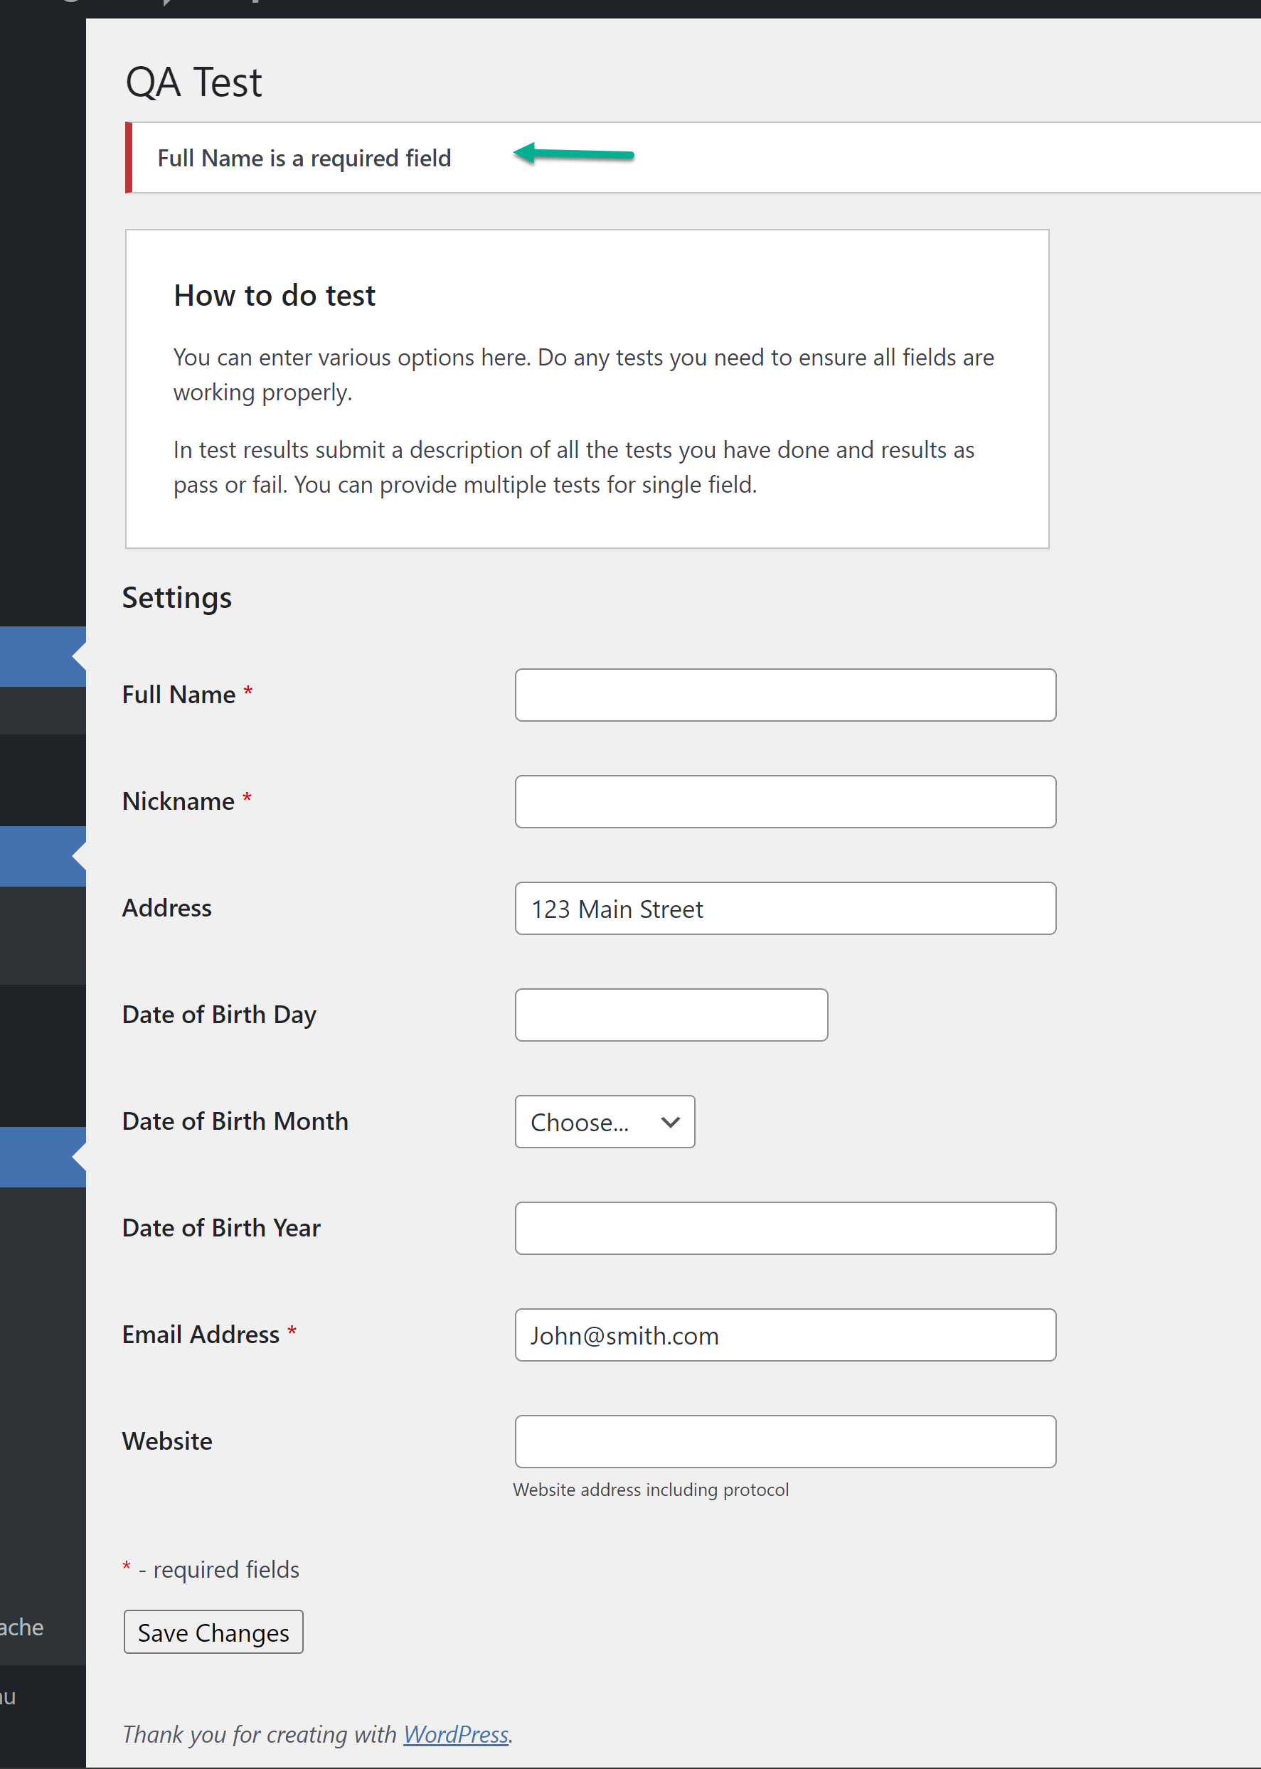

**Test 06**

Verify that **if** all required fields are not filled, the user cannot save entry.

**Test Approach**: This was tested by filling out all required fields except the “Email address” field.

**Test Outcome: FAILED**

**Expected Result**: Error should be thrown for the “Email address” field and user should not be able to save page.

**Actual Result**: Error was NOT thrown for the “Email address” field and user was able to save page.

**Evidence**: All required fields were filled except The “Email Address” field before clicking “Save Changes” button. 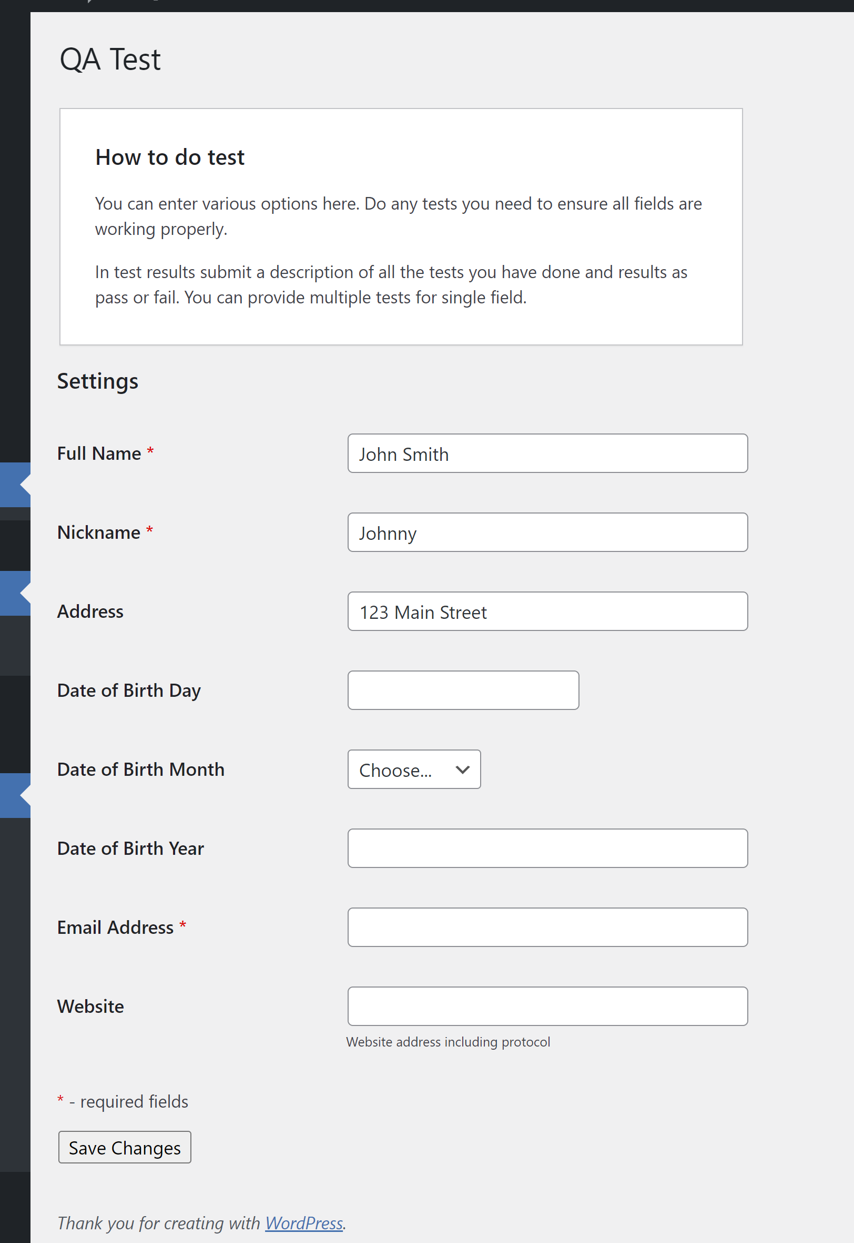

**Evidence**: Error was NOT thrown for the unpopulated “Email address” field but user was able to save page. **FAILED**.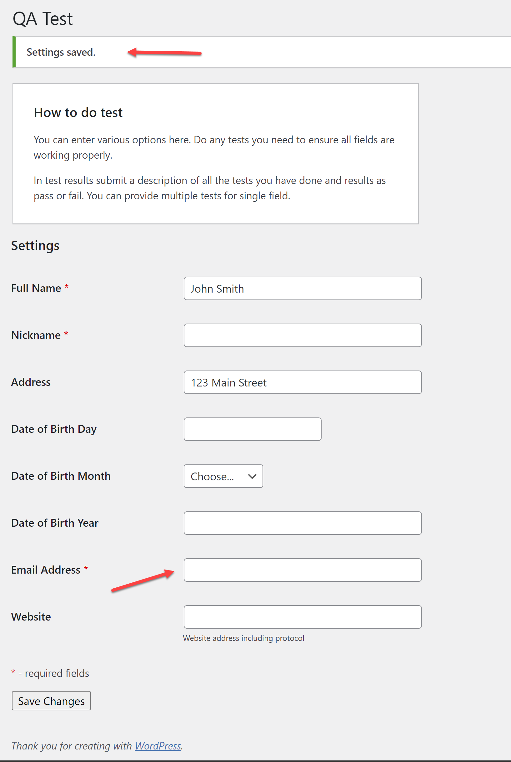

**Test 07**

Verify that **if** all required fields are not filled, the user cannot save entry.

**Test Approach**: This was tested by filling out all required fields except the “Nickname” field.

**Test Outcome: FAILED**

**Expected Result**: Error should be thrown for the “Nickname” field and user should not be able to save page.

**Actual Result**: Error was NOT thrown for the “Nickname” field but user was able to save page.

**Evidence**: All required fields filled except The “Nickname” field before clicking “Save Changes” button. 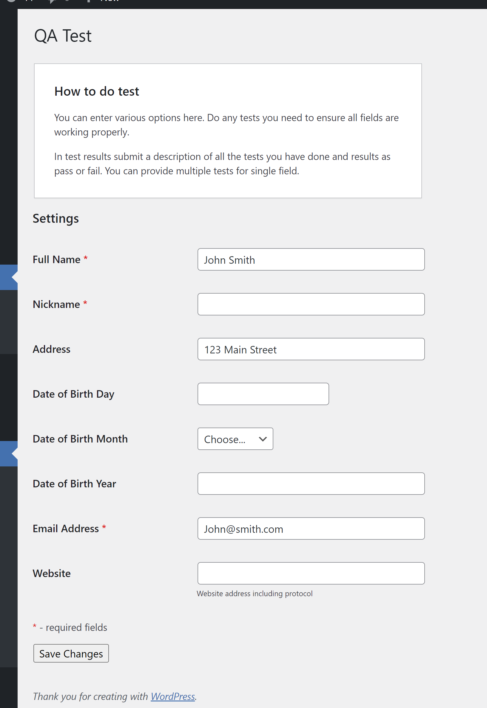

**Evidence**: Error message was NOT thrown for the unpopulated “Nickname” field but user was able to save page. **FAILED**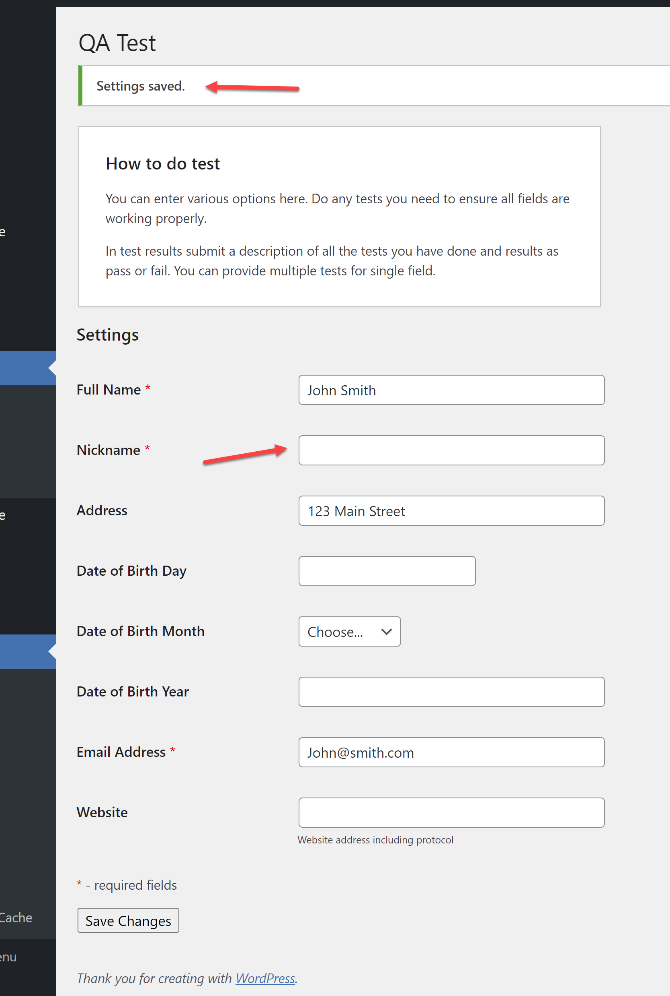

**Test 08**

Verify that the “Full Name” field only takes alpha characters and NOT alpha-numeric or numeric characters.

**Test Approach**: This was tested by populating alpha-numeric characters in the field for the 1st test; and populating all numeric characters for the 2nd test.

**Test Outcome: PASSED**

**Expected Result**: Error message should be thrown for the “Full Name” field for the invalid character type, and user should NOT be able to save page.

**Actual Result**: Error message was successfully thrown, and user was NOT able to save page.

**Evidence**: The “Full Name” field was filled with alphanumeric characters before clicking “Save Changes” button.

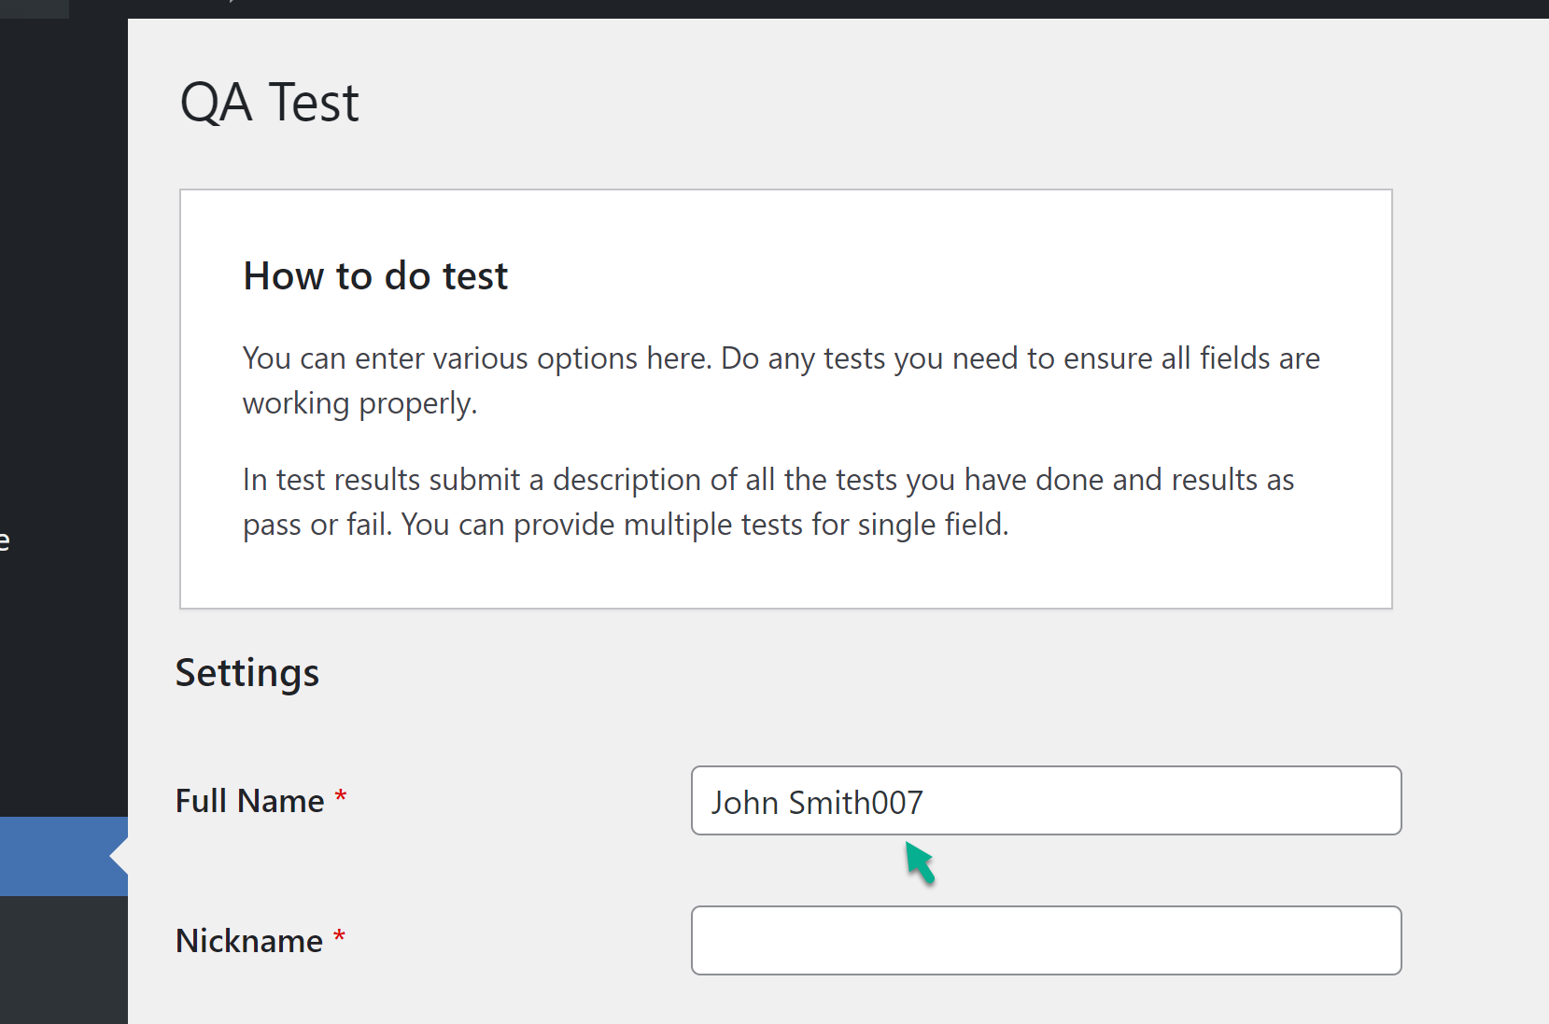

**Evidence**: Error was thrown for invalid character types, and user was NOT able to save page. **PASSED**. 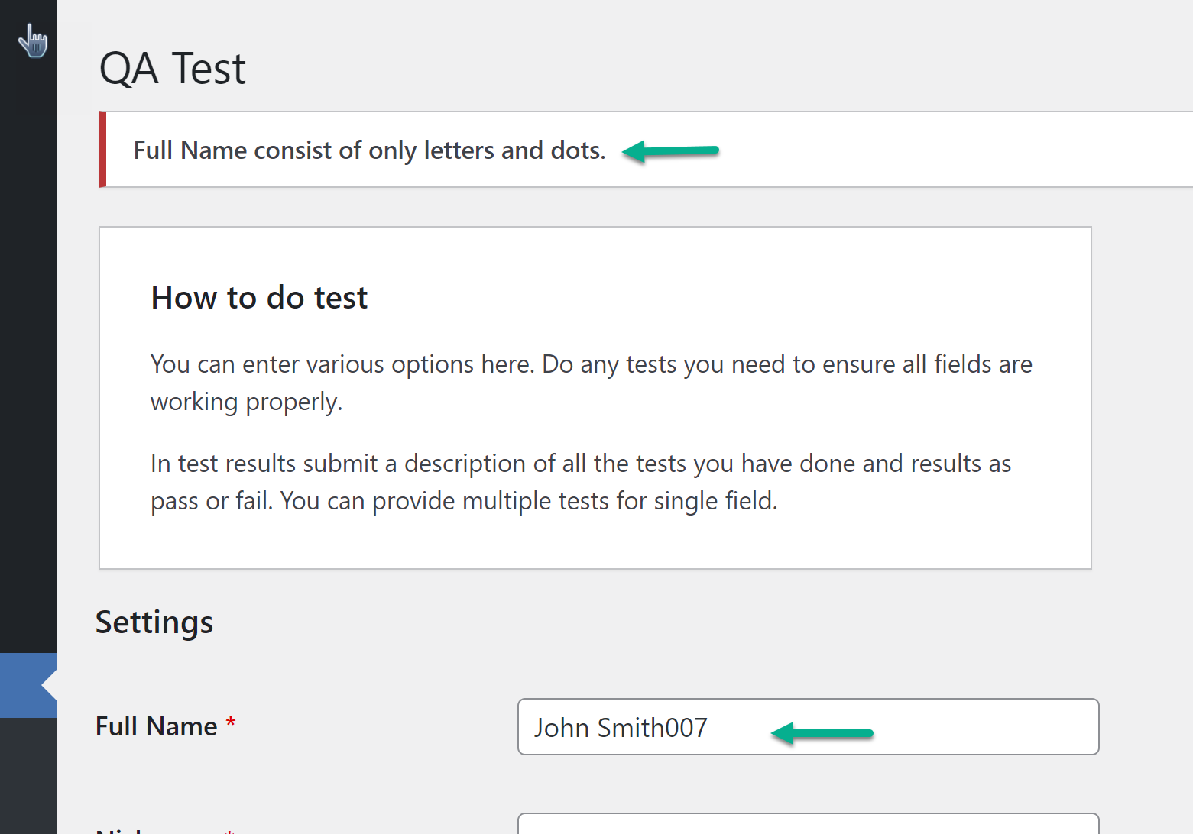 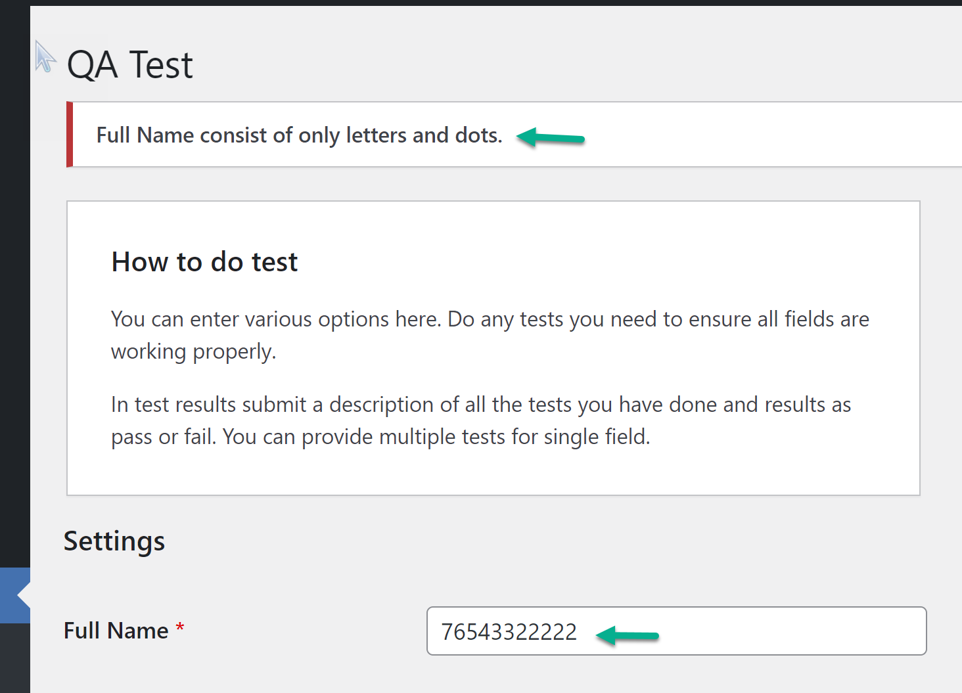

**Test 09**

Verify that the “Full Name” field only takes alpha characters and NOT **special** characters.

**Test Approach**: This was tested by populating special characters in the Full name field along with alpha characterics.

**Test Outcome: FAILED**

**Expected Result**: Error should be thrown for the “Full Name” field for the invalid character type, and user should not be able to save page.

**Actual Result**: Error was NOT thrown, and user was able to save page.

**Evidence**: The “Full Name” field was filled with alpha and special characters before clicking “Save Changes” button.

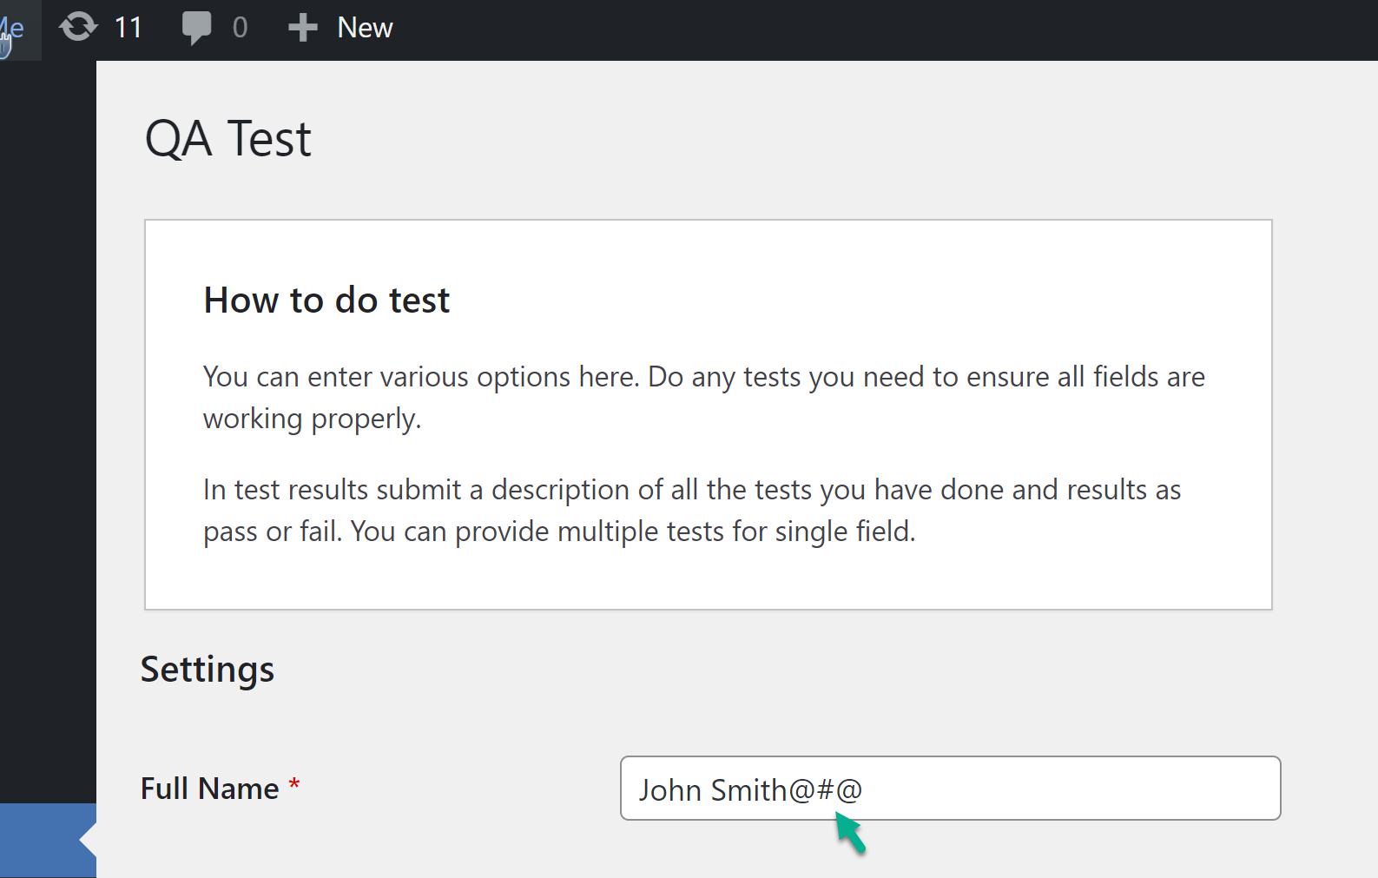

Evidence: Error was NOT thrown for invalid character type, and user was able to save page. **FAILED**.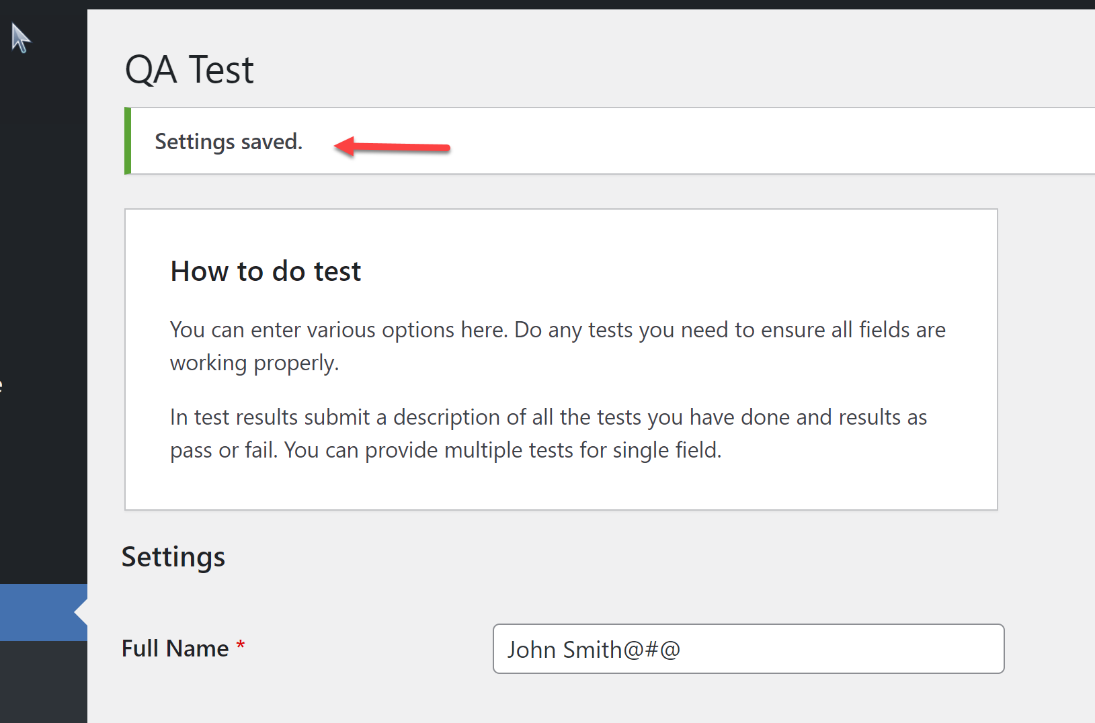

**Test 10**

Verify that the “Date of Birth Year” field only takes values in the accepted value range.

**Test Approach**: This was tested by populating a 5-digit value in the field.

**Test Outcome: PASSED**

**Expected Result**: Error message should be thrown for the “Date of Birth Year” field, and user should not be able to save page.

**Actual Result**: Error was thrown for the “Date of Birth Year” field, and user was NOT able to save page.

Evidence: The “Date of Birth Year” field was filled with 5-digit value before clicking “Save Changes” button

.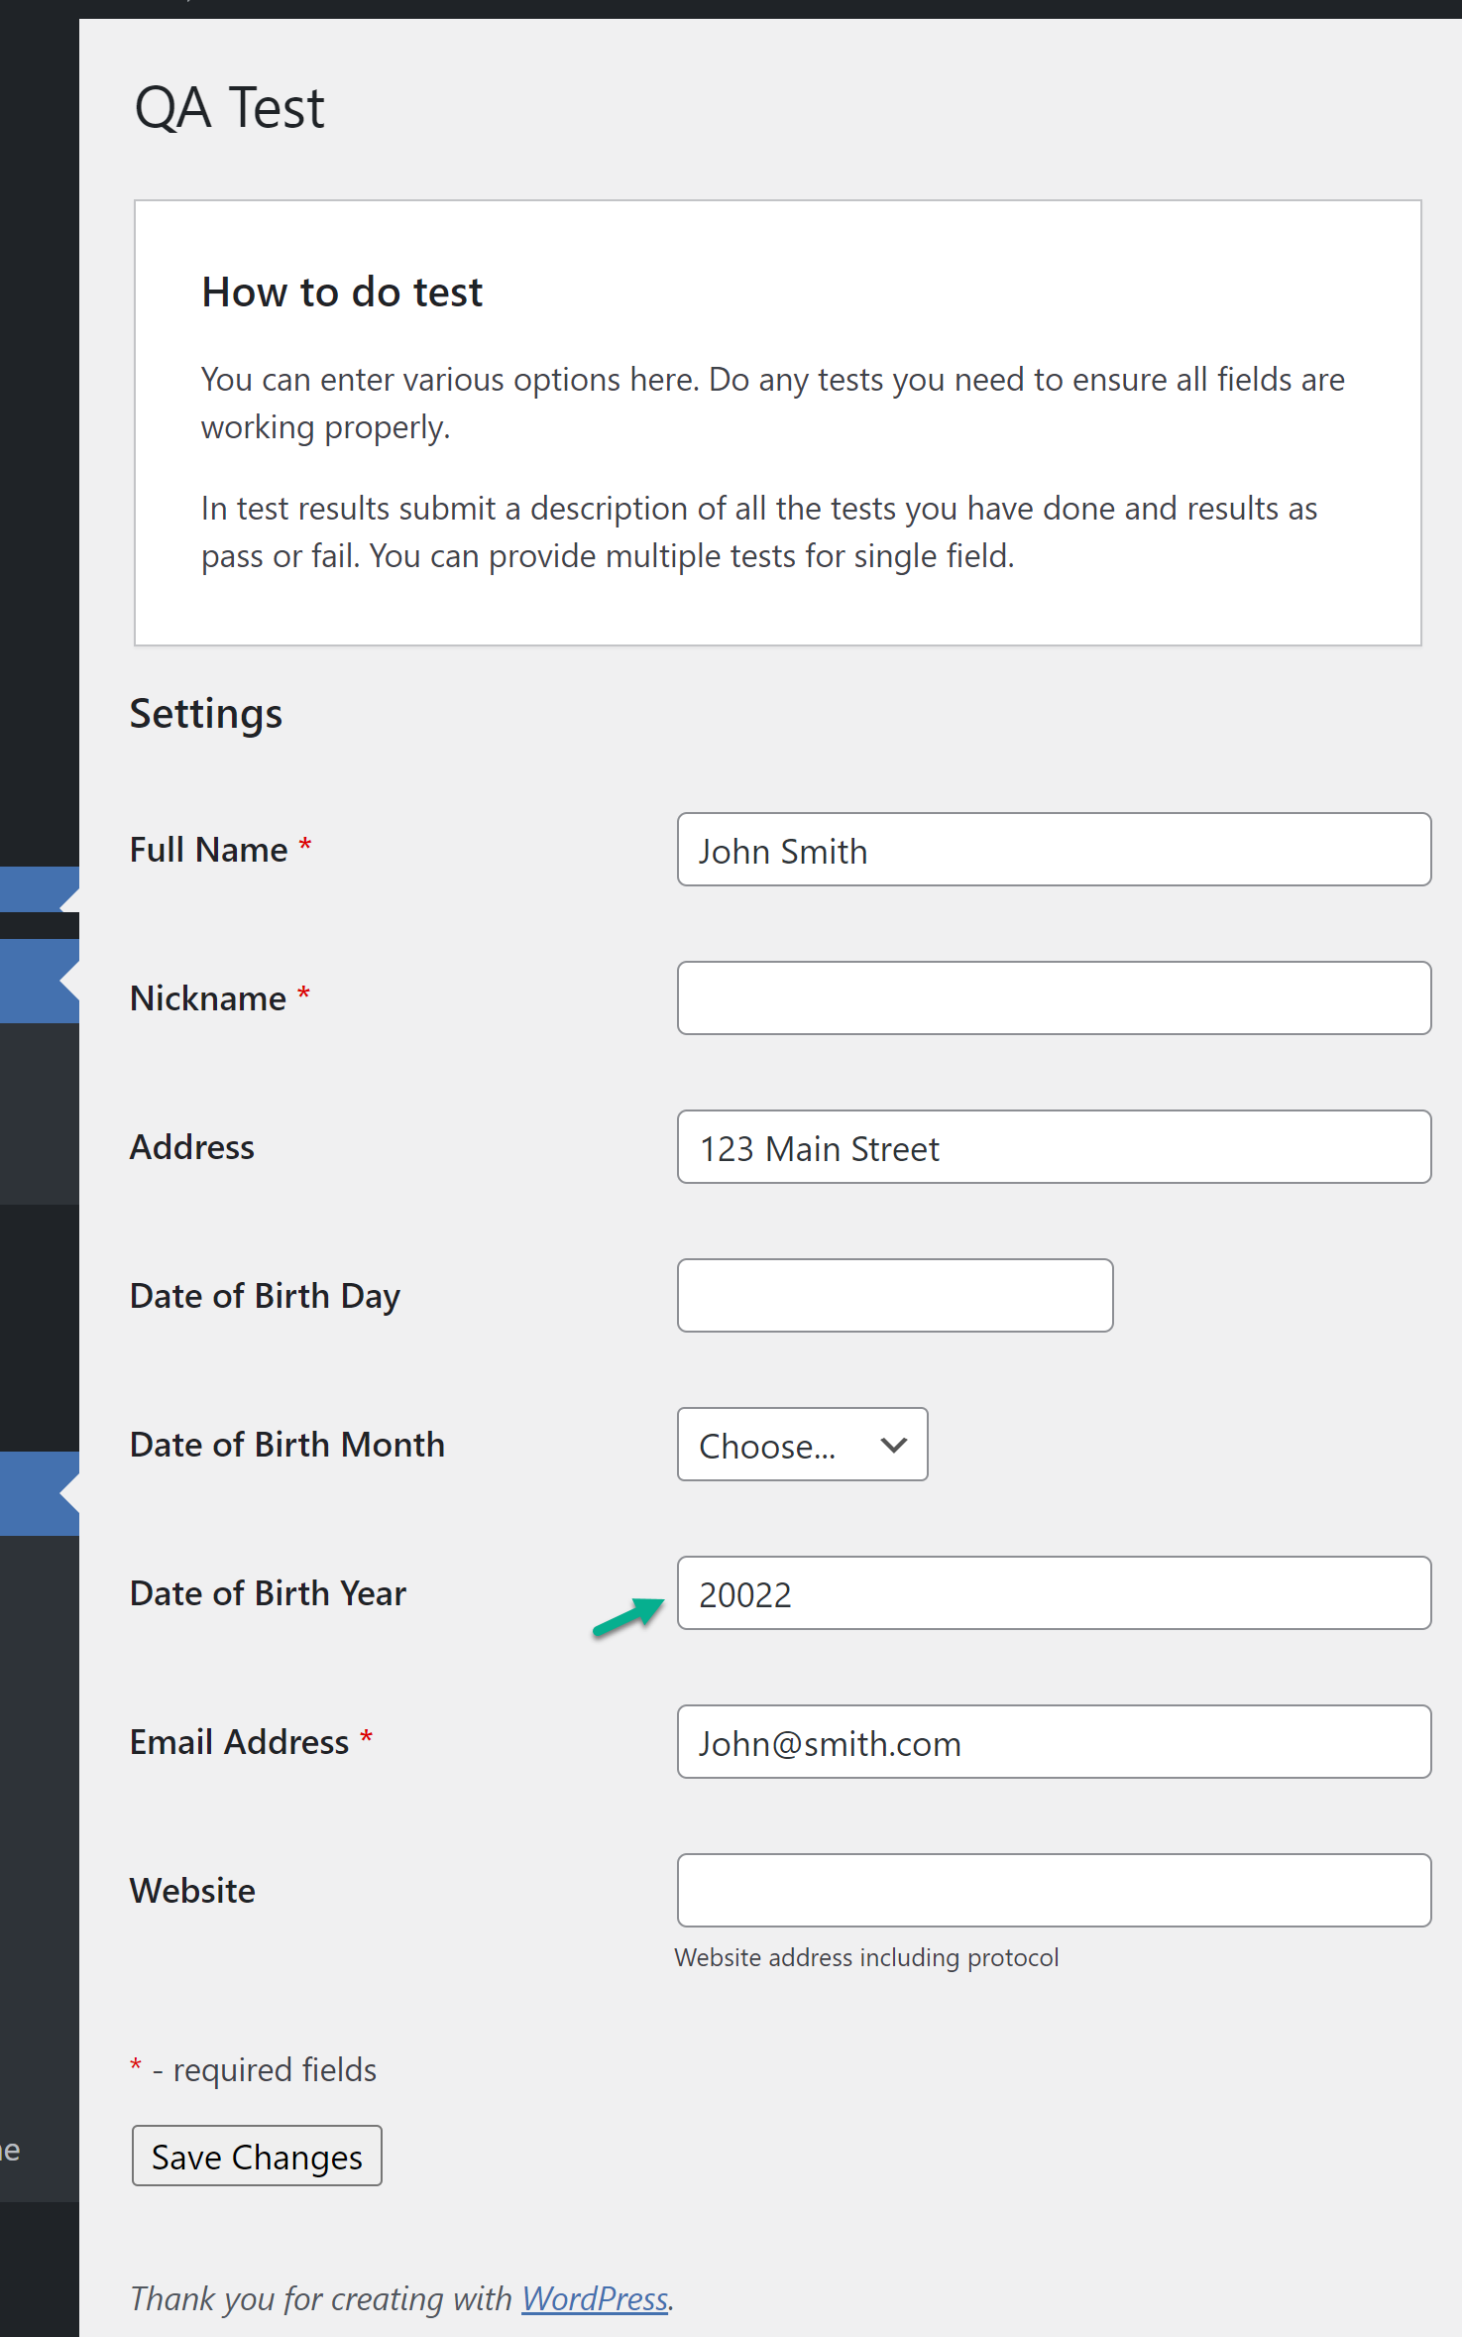

Evidence: Error was thrown for invalid value, and user was NOT able to save page. **PASSED**.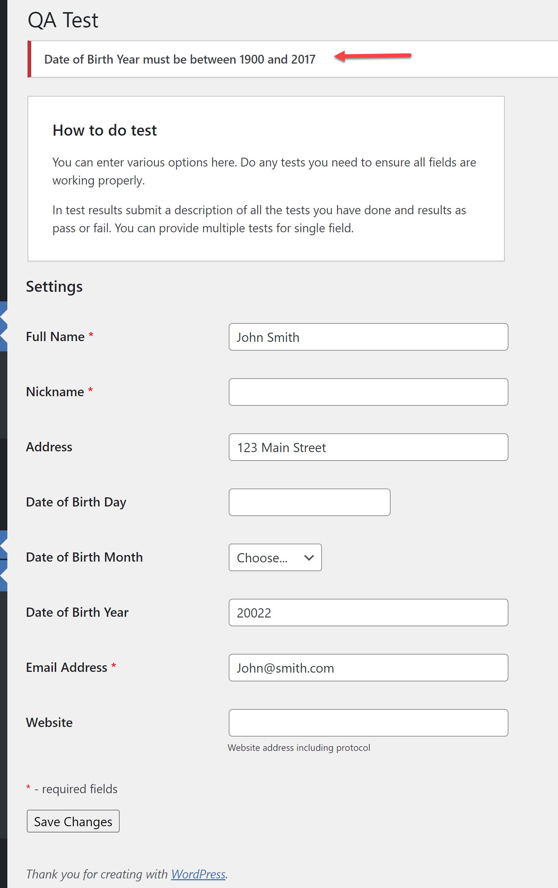

**Test 11**

Verify that the “Date of Birth Year” field accepts value up to the current year.

**Test Approach**: This was tested by populating “2022”in the field.

**Test Outcome: FAILED**

**Expected Result**: Error message should NOT be thrown for the “Date of Birth Year” field, and user should be able to save page.

**Actual Result**: Error was thrown for the “Date of Birth Year” field, and user was NOT able to save page.

**Evidence**: Error was thrown for the current year, and user was NOT able to save page. **FAILED** 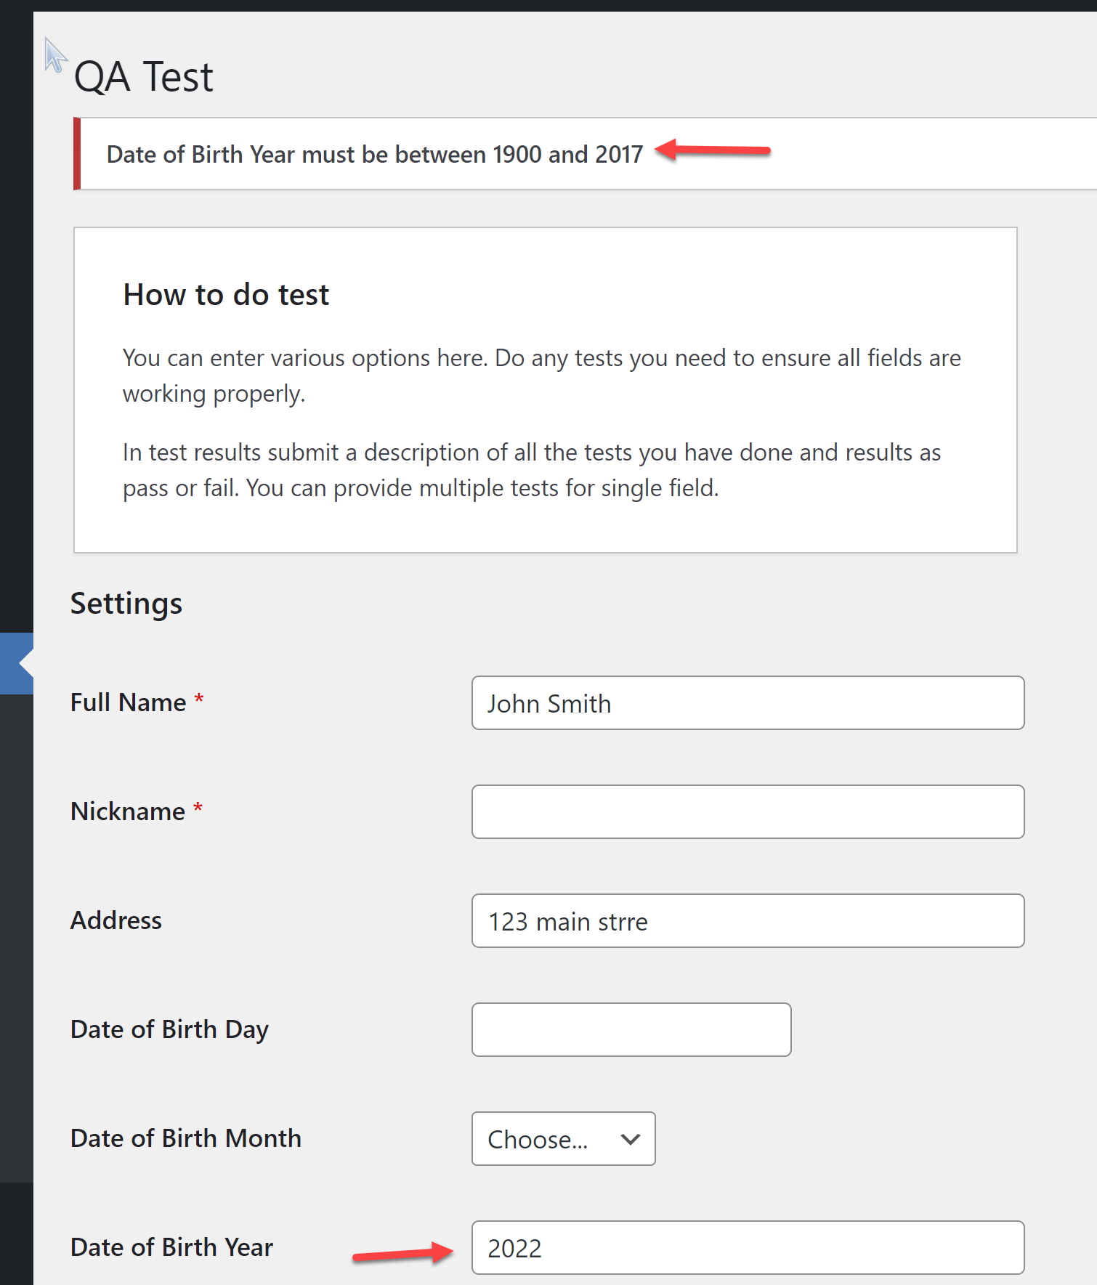

**Test 12**

Verify that the “Date of Birth Day” field only takes numeric values that does not exceed “31.”

**Test Approach**: This was tested by populating a value greater than 31 in the field.

**Test Outcome: FAILED**

**Expected Result**: Error should be thrown for the field, and user should not be able to save page if the maximum value of 31 is exceeded.

**Actual Result:** Error was NOT thrown, and user was able to save page.

**Evidence**: The field was populated with “55” before clicking “Save Changes” button.

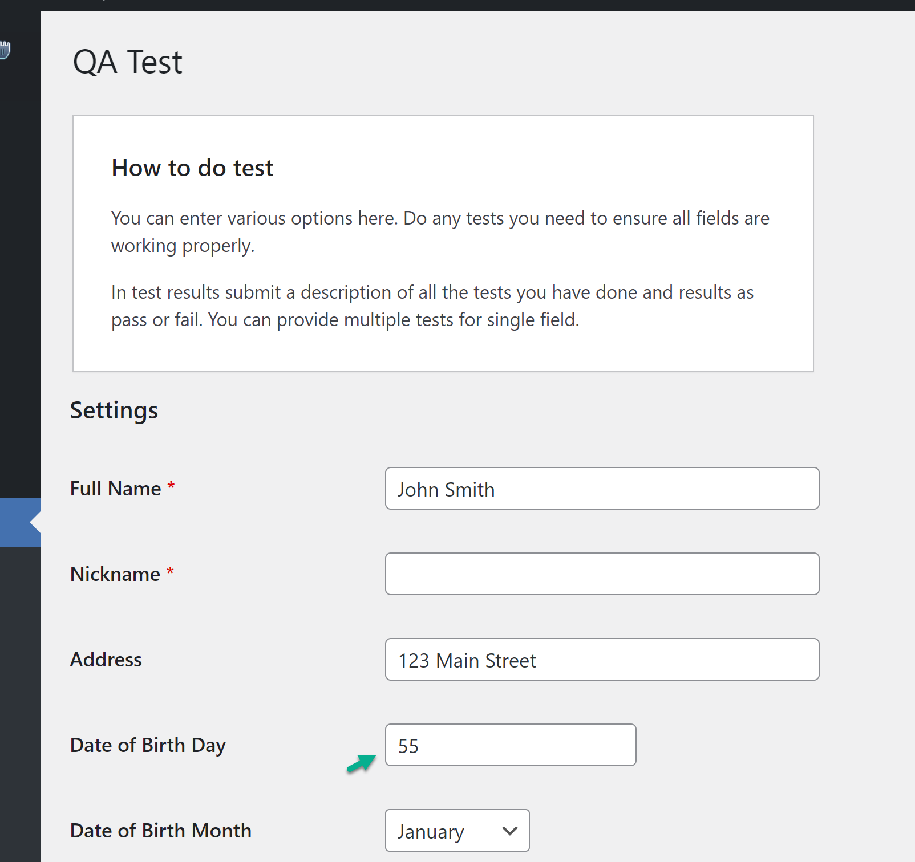

**Evidence**: Error message was NOT thrown, and user was able to save page. **FAILED**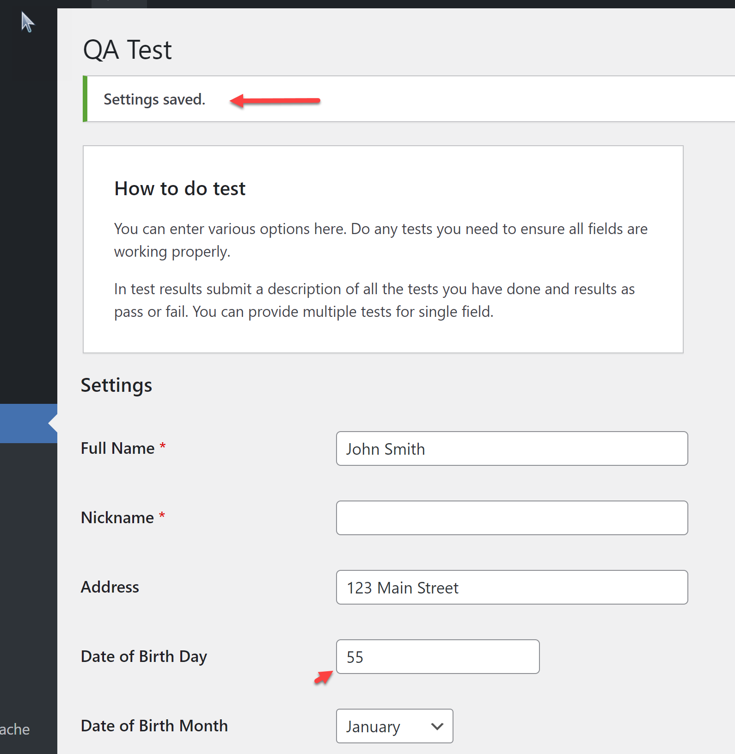

**Test 13**

Verify that the “Date of Birth Day” field does NOT take values below “1.”

**Test Approach**: This boundary value test was executed by populating the field with 0 and then a negative value.

**Test Outcome: FAILED**

**Expected Result**: Error should be thrown for the field, and user should not be able to save page if value is below “1.”

**Actual Result:** Error was NOT thrown, and user was able to save page.

**Evidence**: The field was populated with <1 values before clicking “Save Changes” button. 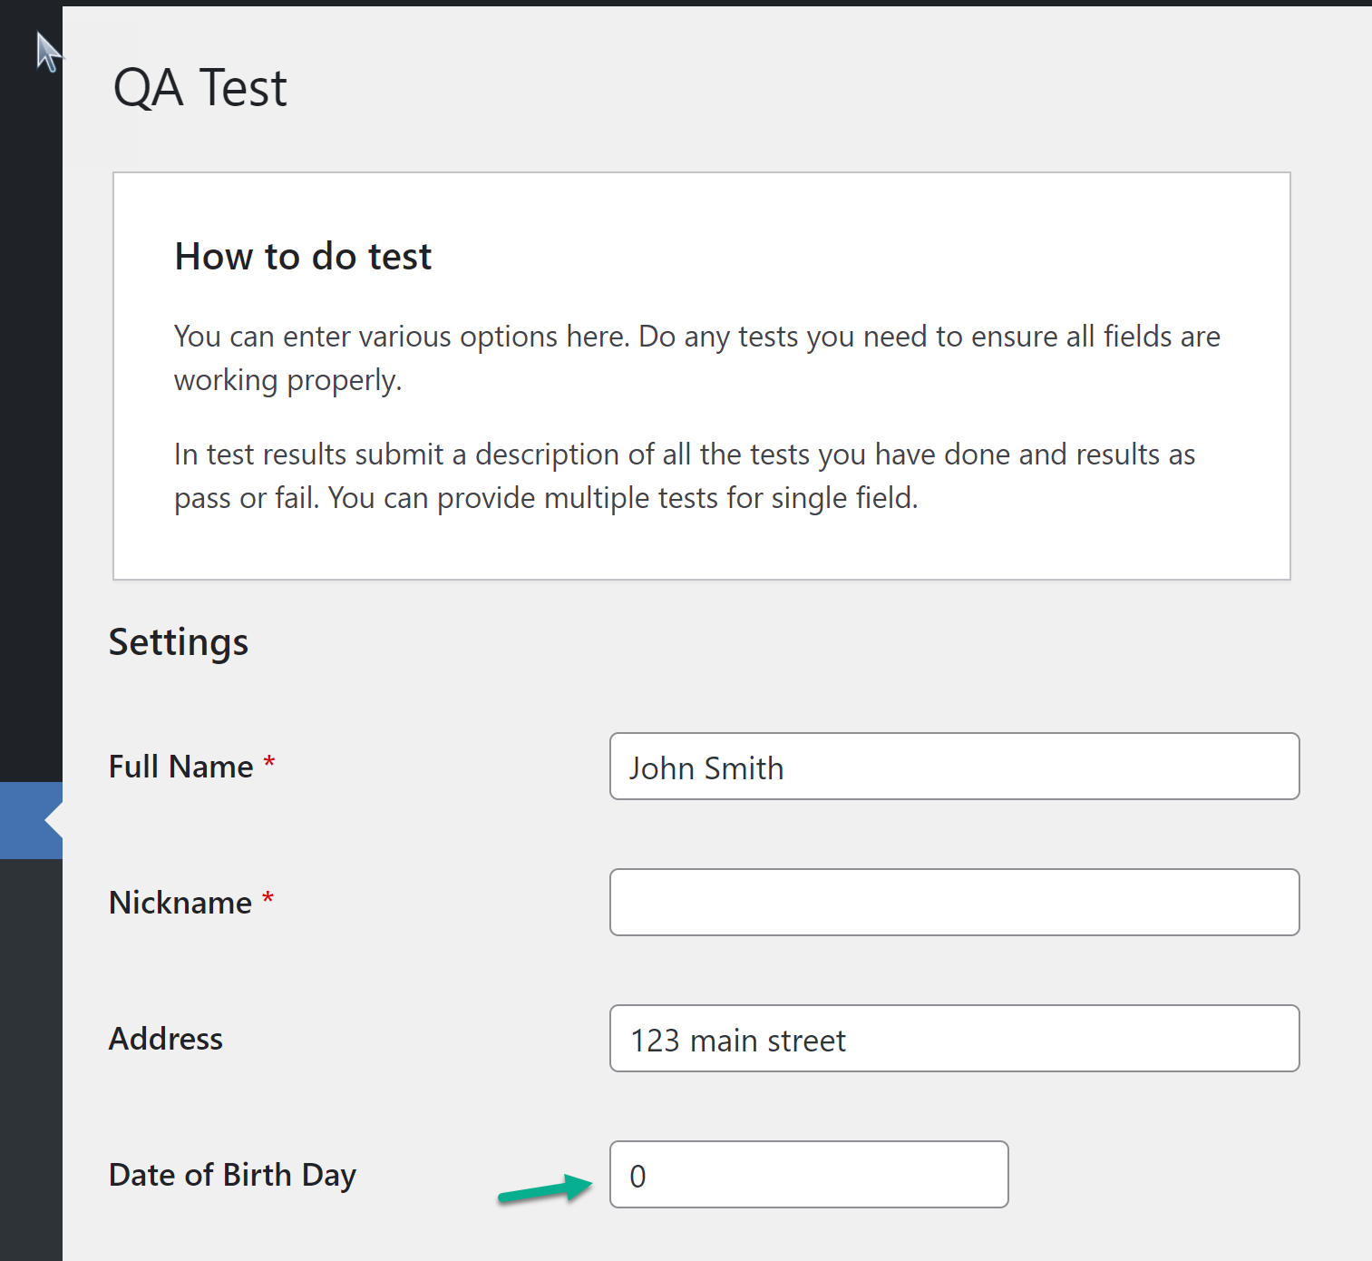

**Evidence**: Error message was NOT thrown for value of “0”, and user was able to save page. **FAILED** 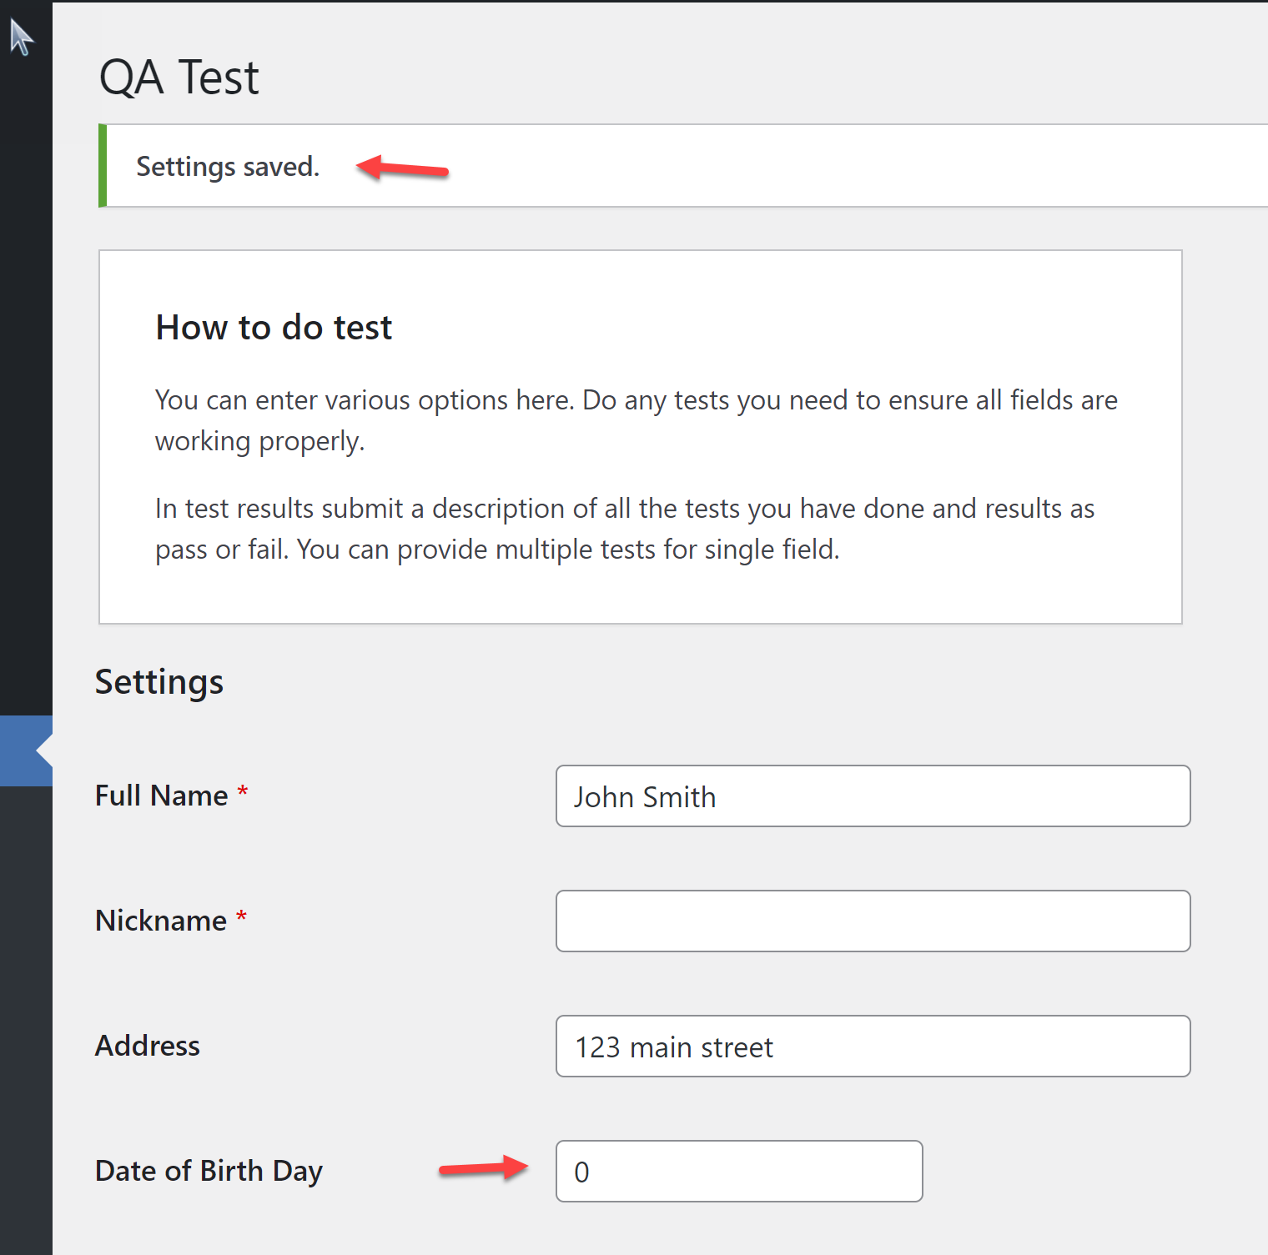

**Evidence**: Error message was NOT thrown for value of “-3”, and user was able to save page. **FAILED** 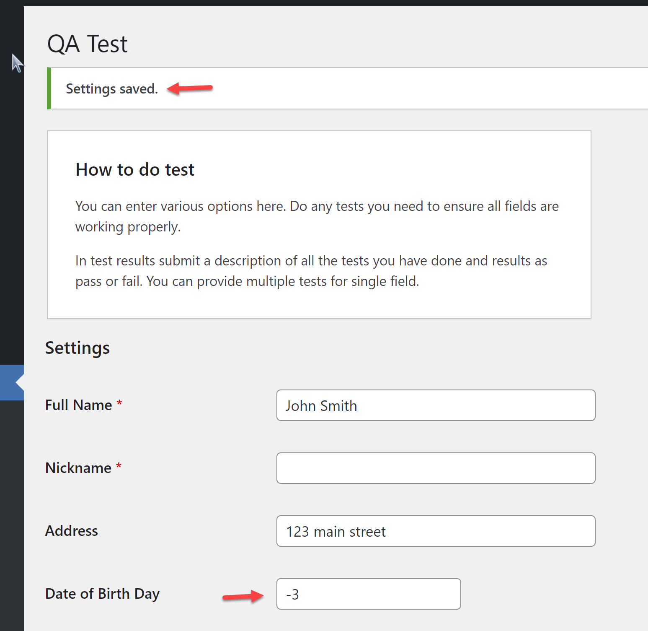

**Test 14**

Verify that the “Email Address” field requires that “.com” is entered before page can be saved.

**Test Approach**: This was tested by not populating “.com” in the entered email address.

**Test Outcome: PASSED.**

**Expected Result**: Error message should be thrown, and user should NOT be able to save page.

**Actual Result**: Error message was thrown, and user was NOT able to save page.

**Evidence**: “.com” was NOT populated for the email address before clicking “Save Changes” button.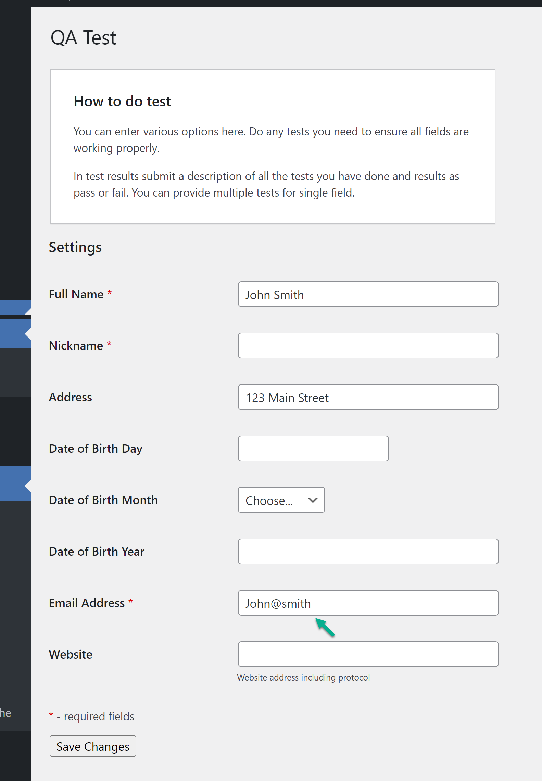

**Evidence**: Error message was thrown, and user was NOT able to save page. **PASSED**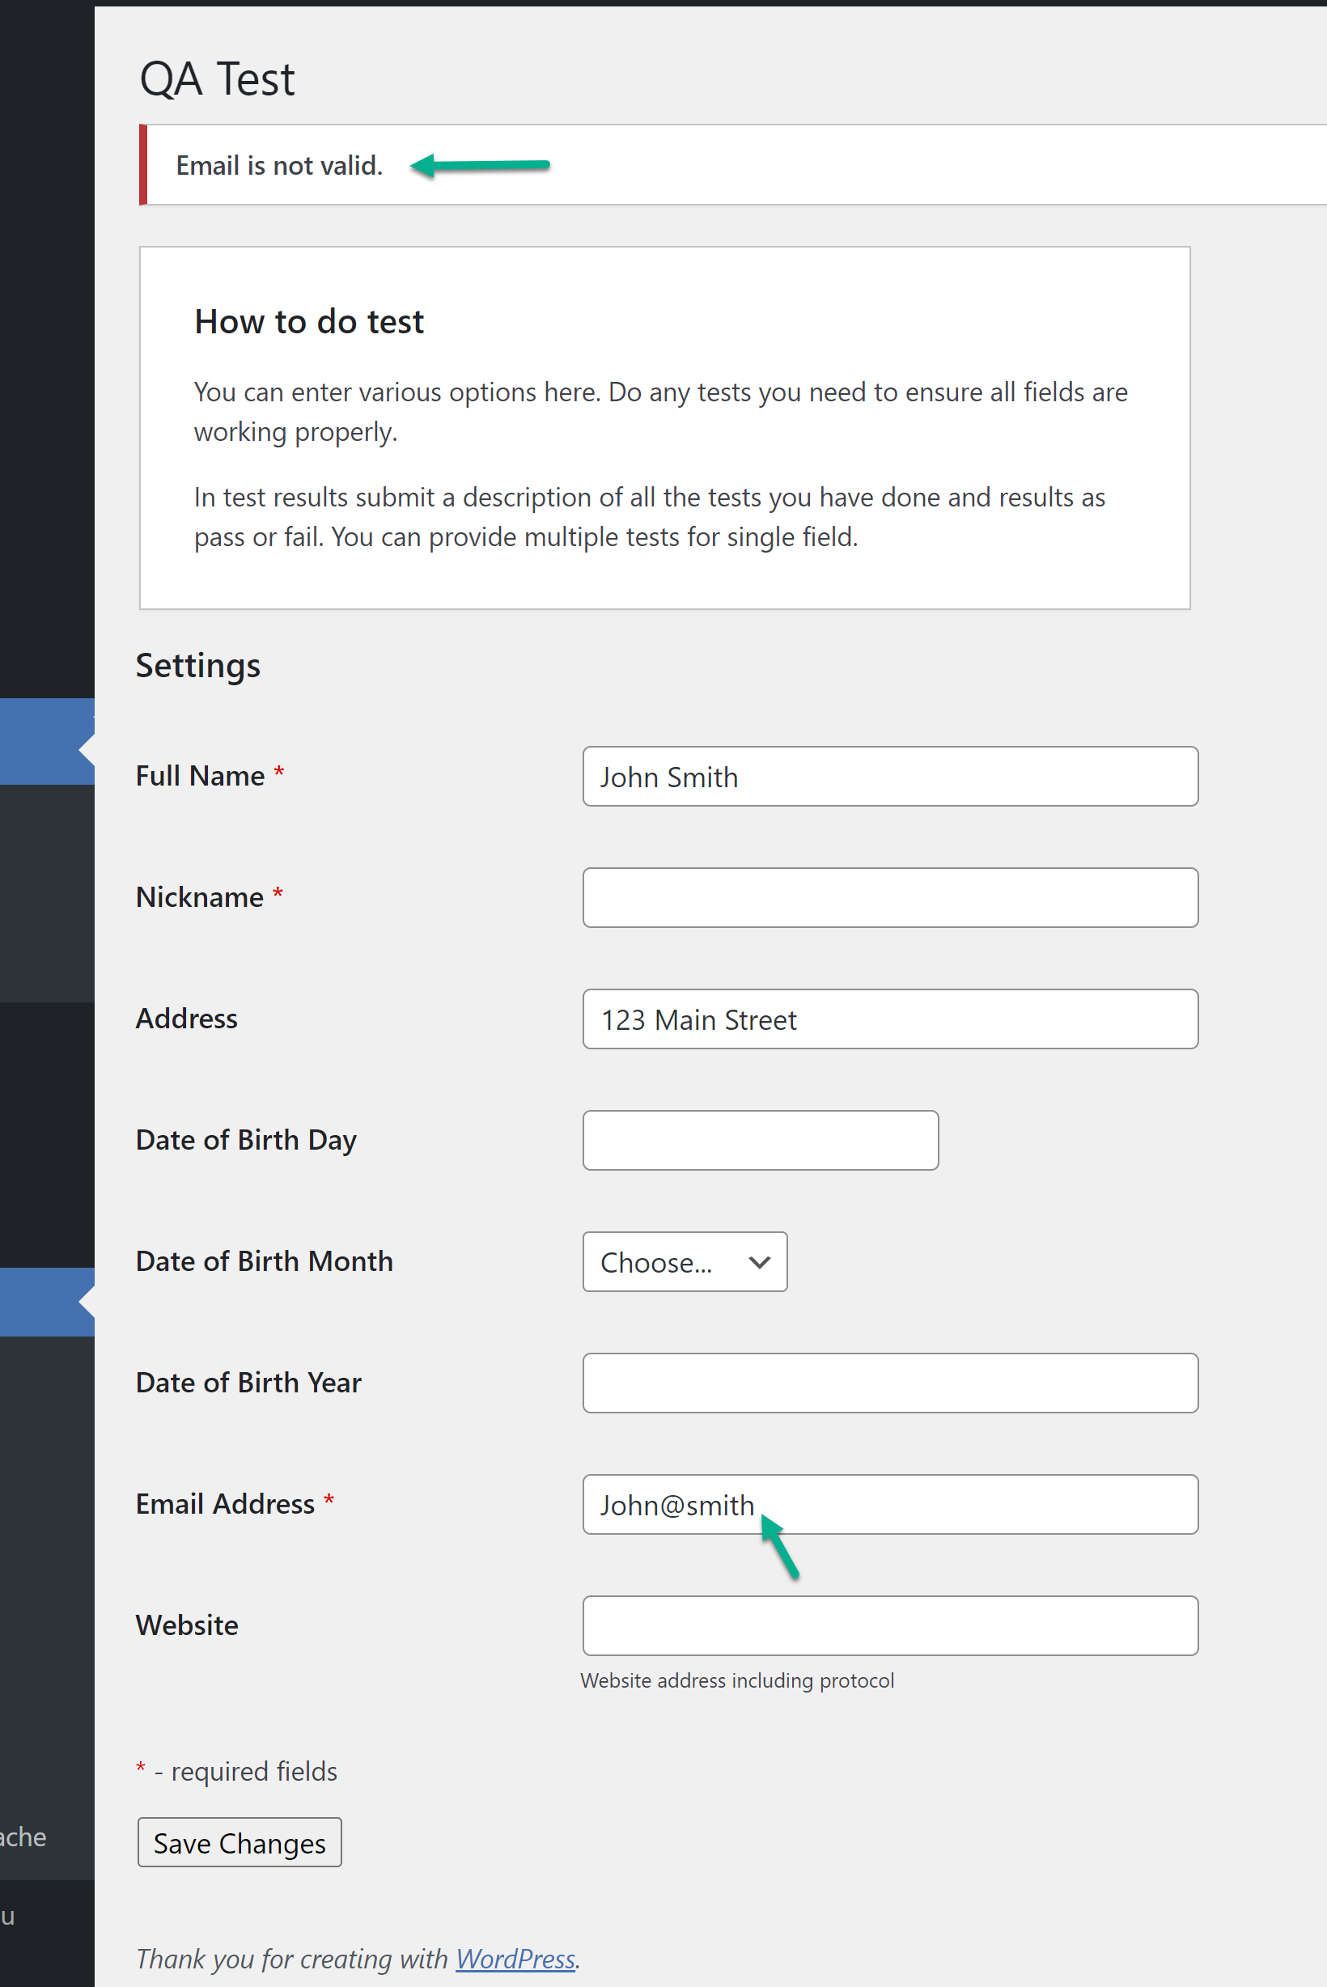

**Test 15**

Verify that the “Email Address” field only takes the allowed special character in its format.

**Test Approach**: This was tested by populating “&” instead of “@” in the entered email address.

**Test Outcome: PASSED**

**Expected Result**: Error message should be thrown for the “Email Address” field, and user should not be able to save page.

**Actual Result:** Error message was thrown, and user was NOT able to save page.

**Evidence**: “&” was populated instead of “@” for email before clicking “Save Changes” button 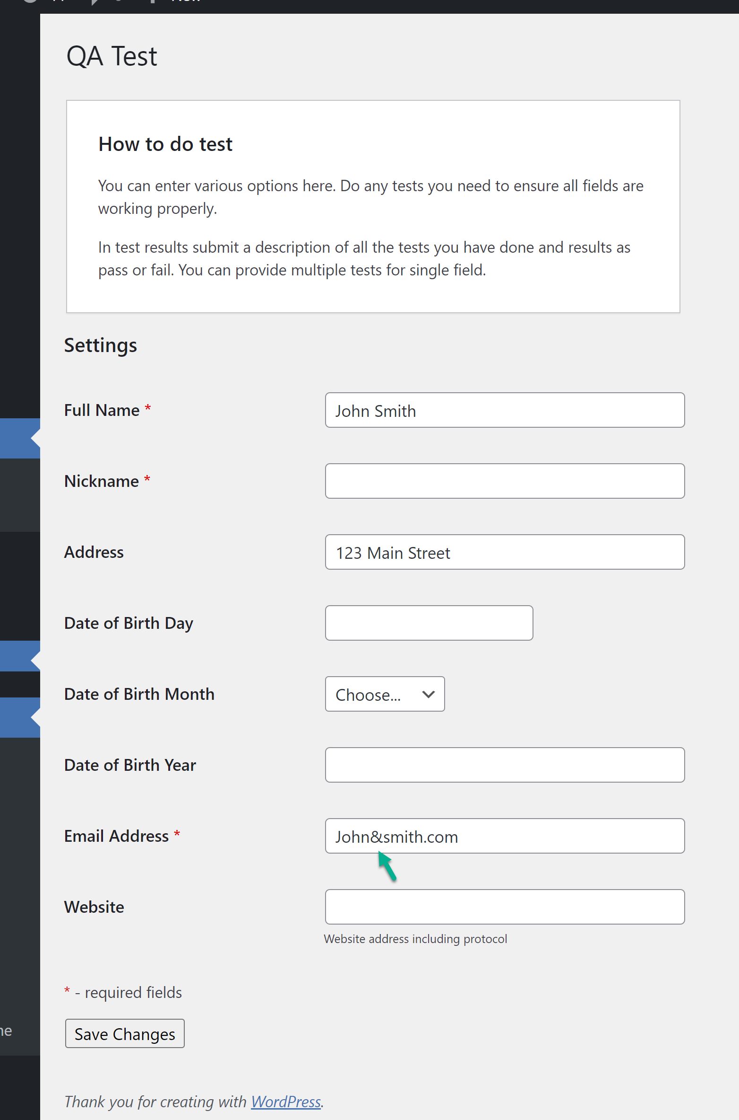

**Evidence**: Error message was thrown, and user was NOT able to save page. **PASSED**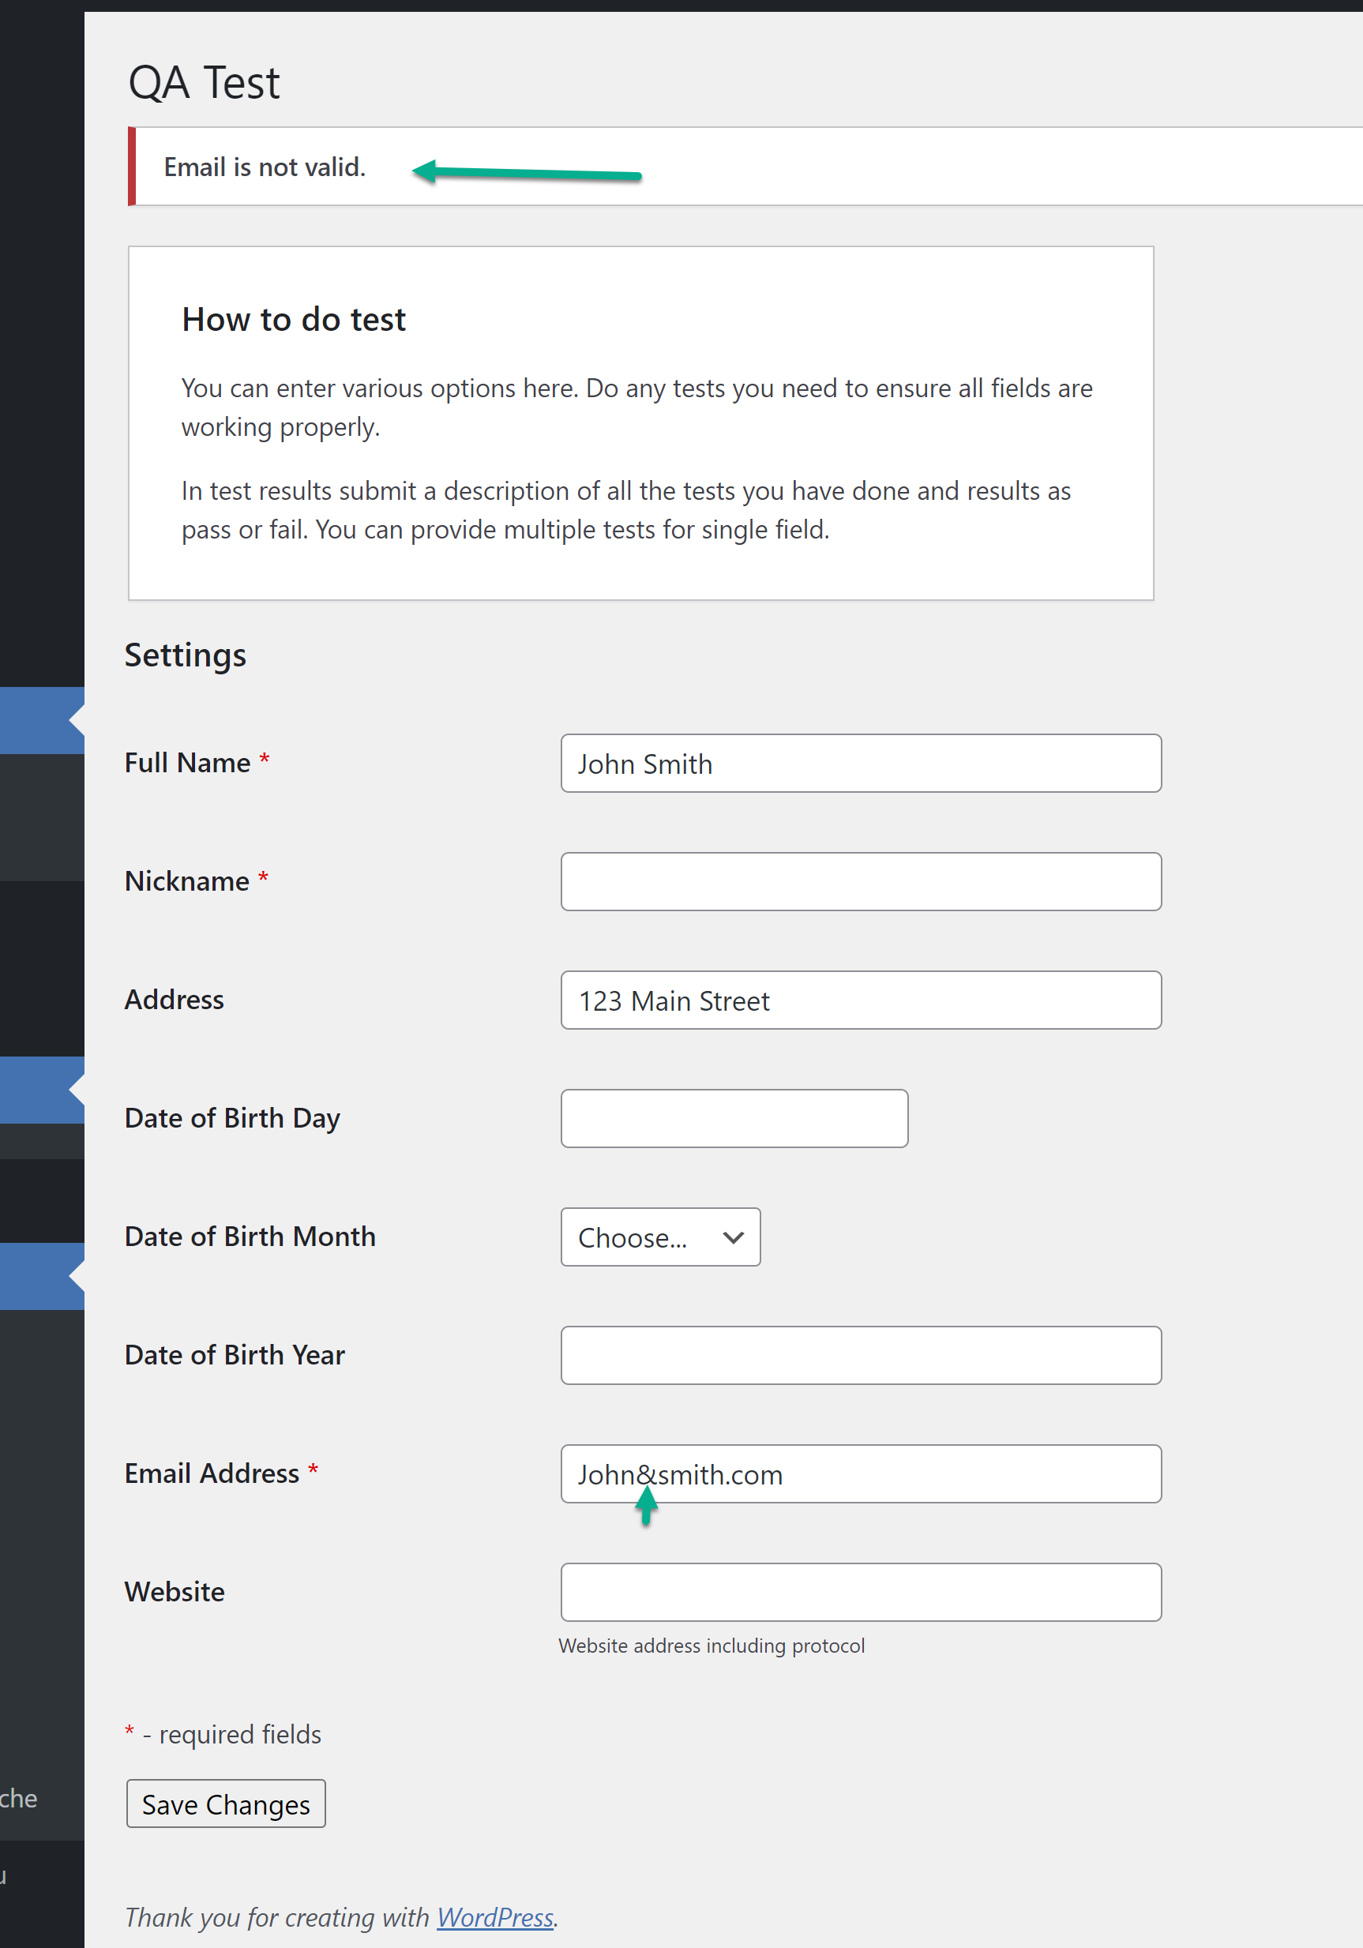

**Test 16**

Verify that the the values popuplated in the “Website” field includes protocol.

**Test Approach**: This was tested by not populating ”https://” in the entered website URL.

**Test Outcome: PASSED**

Expected Result: Error message should be thrown for the “Website” field, and user should not be able to save page.

Actual Result: Error was thrown, and user was NOT able to save page.

**Evidence**: ”https://” was not populated in website URL before clicking “Save Changes” button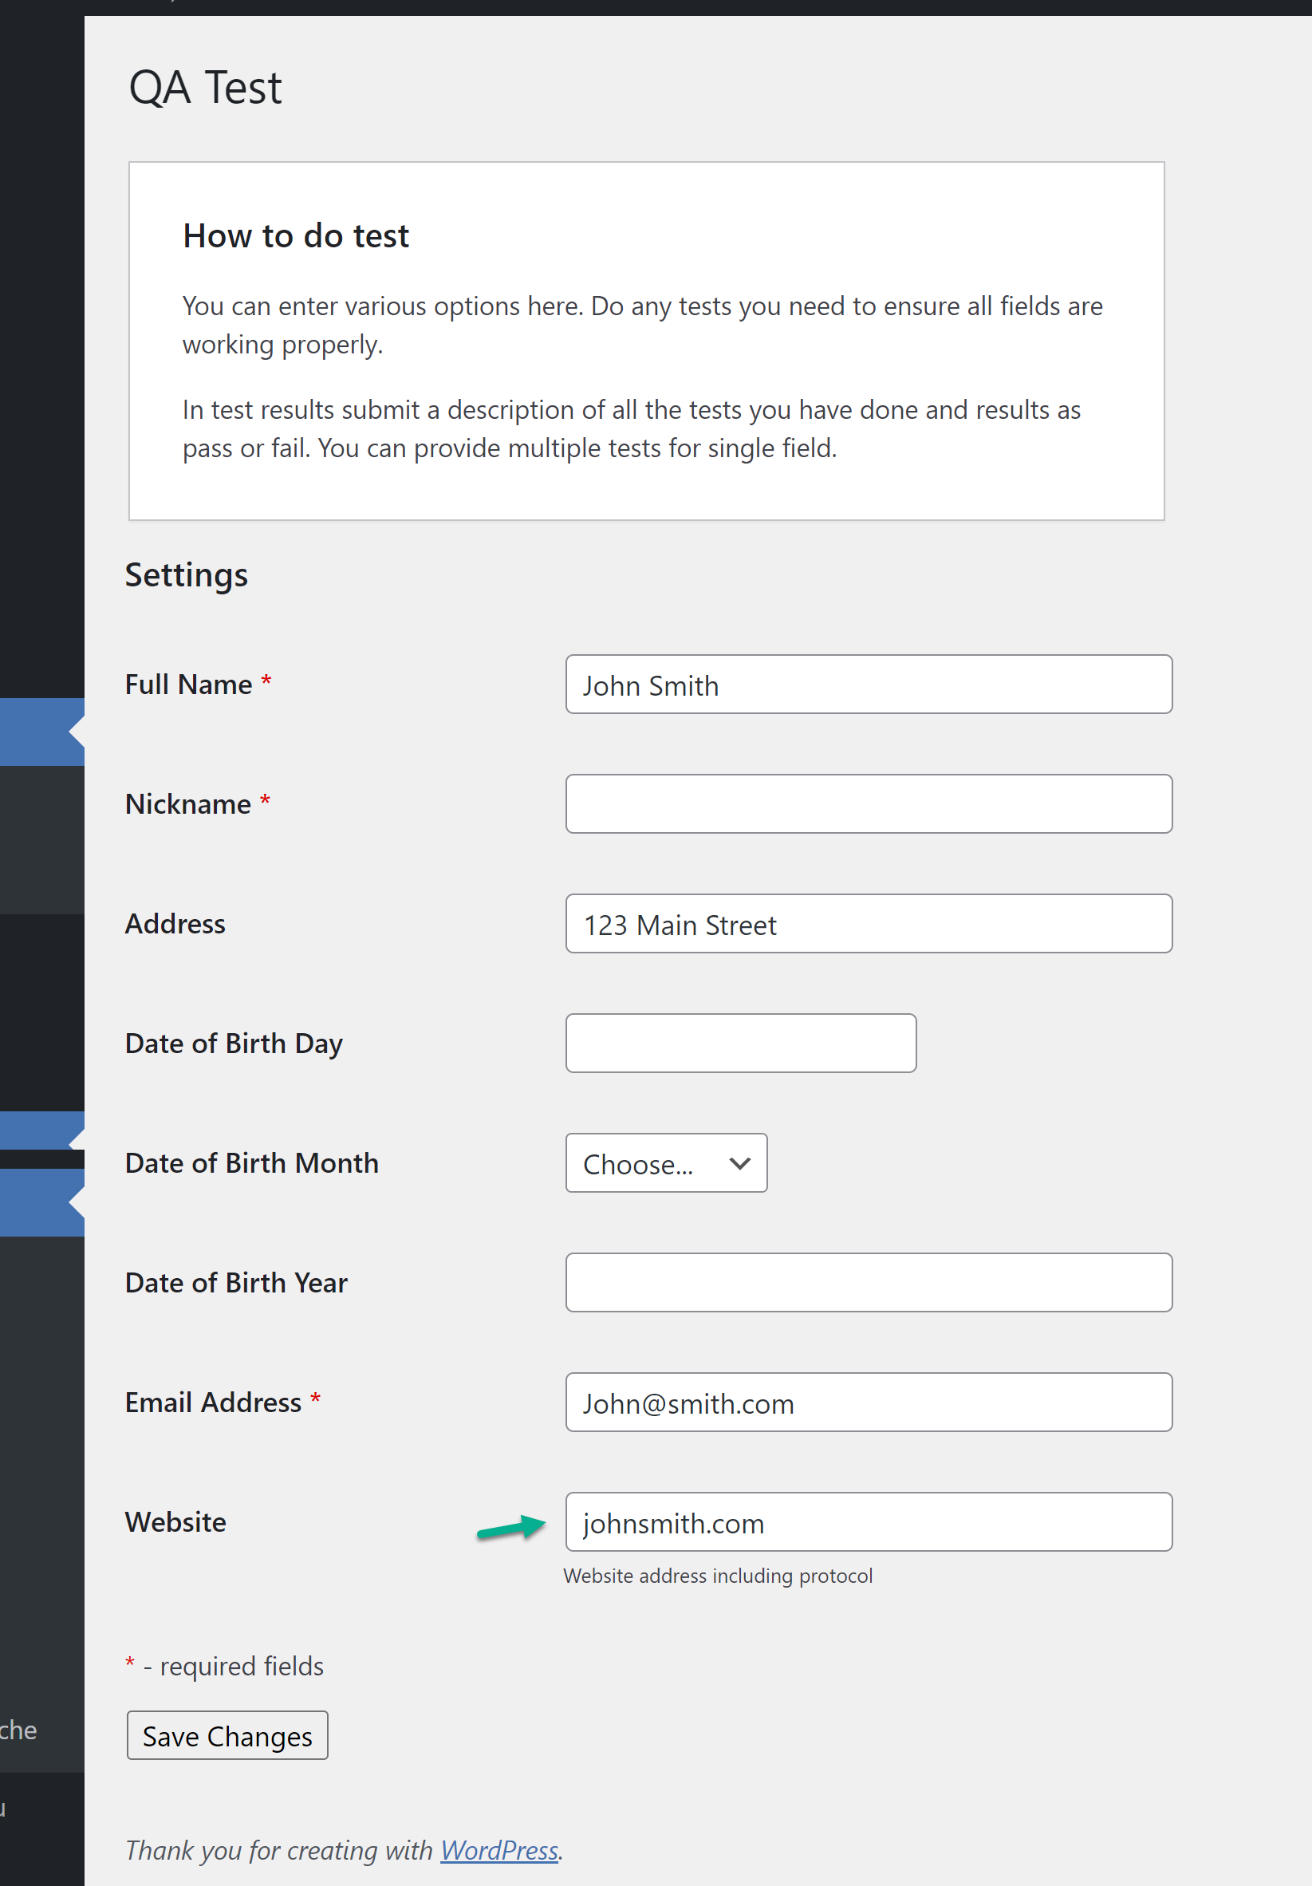

**Evidence**: Error message was thrown, and user was NOT able to save page. **PASSED**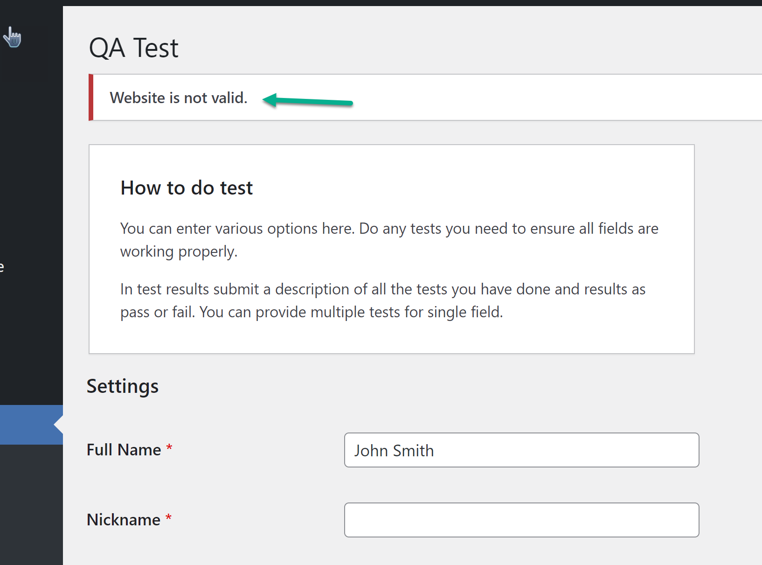

**Test 16**

Verify plugin can be successfully deactivated in WordPress.

**Test Outcome: PASSED**

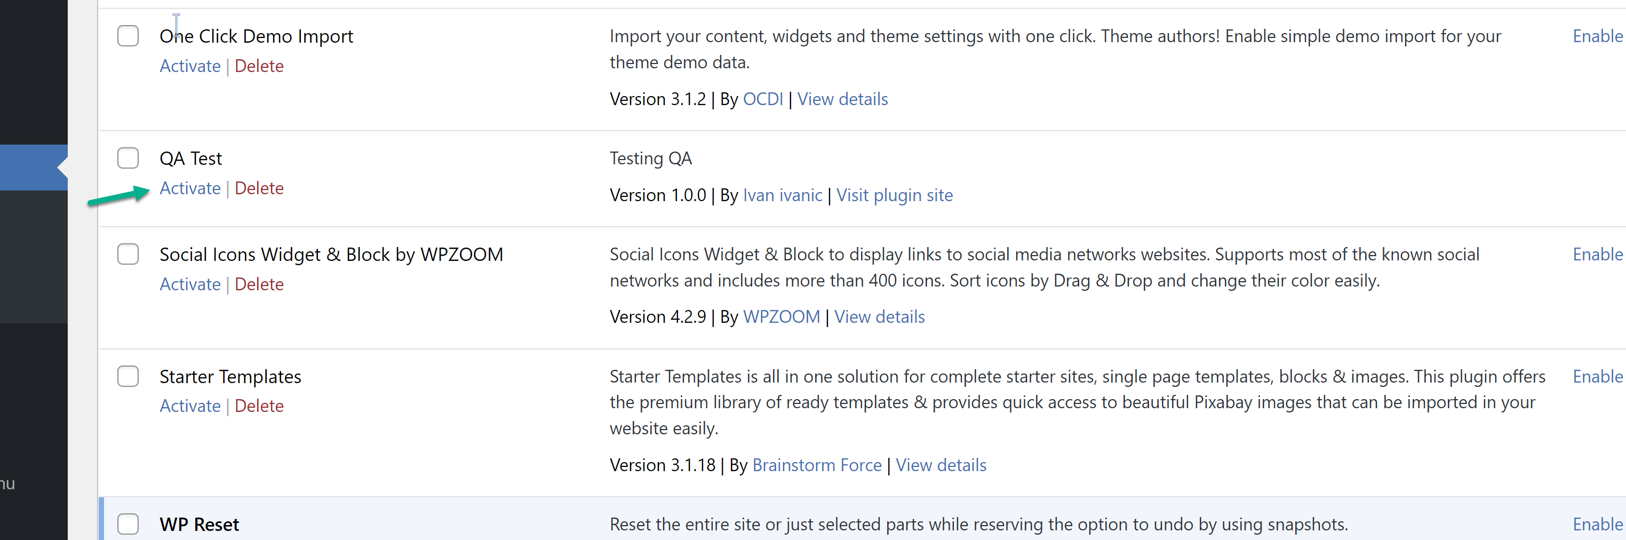 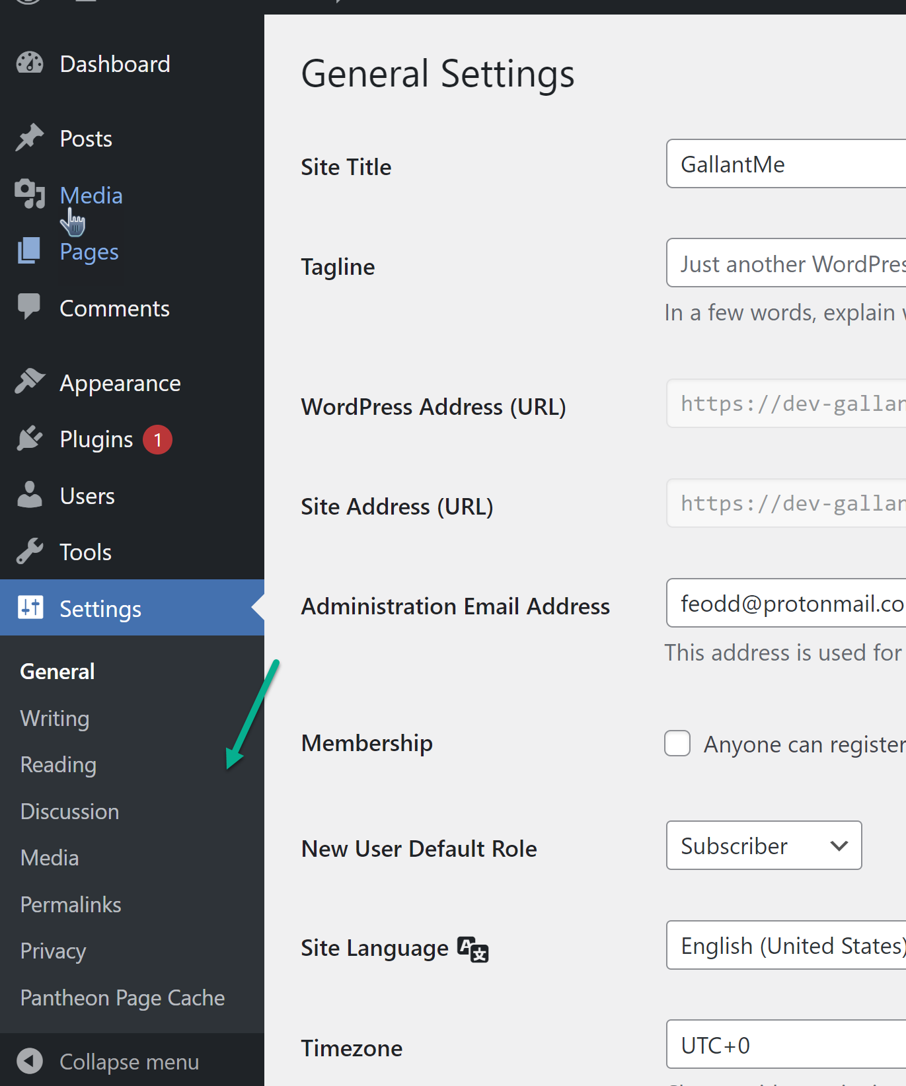

**Summary of defects.**

The below defects were encountered during test execution. They were all retested to ensure they were consistent defects. They can be log in the appropriate defect tracking tool so that the dev team can start working to get them resolved, and them retested to validate fix.

1. The “Address” field should Not be a required field but currently is.
2. The “Nickname” field should be a required field but currently is NOT.
3. The “Email Address” field should be a required field but currently is NOT.
4. The text entered in the “Nickname” field is not retined after page is saved.
5. The text entered in the “Website” field is not retained after page is saved
6. The “Full Name” field is currently accepting special characters.
7. The “Date of Birth Year” field value range is defective. It does not extend to the current year of 2022. Only extends to 2017.
8. The “Date of Birth Day” field is accepting value greater than 31.
9. The “Date of Birth Day” field is accepting values lower than 1.